

Honours Project – MHI130252
Final Report
2025-2026
Department of Cyber Security and Networks
Submitted for the Degree of:

BSc (Hons) Cyber Security and Networks

Project Title: Security Issues and Defence Mechanisms in (Vehicular Ad Hoc Networks) VANET
Name: Dawud Raziq
Matriculation Number: S2215076
Project Supervisor: Salma Mohammed
Second Marker: Anand Phillip
Word Count: 9,976
(excluding contents pages, figures, tables, references and Appendices)
Aligned to SDGs: 3, 9, 11
“Except where explicitly stated, all work in this report, including the appendices, is my own original work and has not been submitted elsewhere in fulfilment of the requirement of this or any other award”

Signed by Student: 
Date: 17/04/2026

Abstract
The rapid development of Vehicular Ad Hoc Networks (VANETs) has introduced significant security challenges within their decentralised and highly dynamic communication environments. Among these, the Ad hoc On-Demand Distance Vector (AODV) routing protocol is particularly vulnerable to Black hole attacks, where malicious nodes exploit the route discovery process to intercept and drop data packets, leading to severe network degradation and compromised road safety communications.
This research proposes, implements, and evaluates a hybrid Intrusion Detection System (IDS) designed to mitigate Black hole attacks through a defence-in-depth architecture. The proposed framework integrates a signature-based IDS to detect control-plane anomalies, specifically sequence number manipulation, with a behavioural trust-based routing mechanism that monitors packet forwarding behaviour to identify and isolate malicious nodes at the data plane.
The system was implemented at the AODV protocol level within the Network Simulator 2 (NS-2.35) environment and evaluated across a 20-node network under varying attack intensities (10%, 25%, and 50% malicious nodes). Performance was assessed using key metrics including Packet Delivery Ratio (PDR), throughput, end-to-end delay, detection rate, and false positive rate.
The results demonstrate that while standalone security mechanisms provide partial mitigation, the hybrid approach offers improved resilience under diverse attack conditions. Notably, the integration of signature-based filtering with trust-based routing reduces false positives and enhances detection accuracy, while maintaining acceptable network performance. Under high-intensity attack scenarios (50%), the proposed model improves PDR and throughput compared to standalone approaches, demonstrating its effectiveness in sustaining network functionality in adversarial environments.
Overall, this study highlights the importance of combining proactive and reactive security mechanisms to address both control-plane and data-plane threats. The findings suggest that hybrid IDS–trust frameworks represent a practical and lightweight solution for enhancing VANET security, with potential applicability in real-time intelligent transportation systems.
Acknowledgments

I would like to thank my supervisor Salma Mohammed for her consistent support and advice throughout my Honours Project.

Contents
List of Figures 5
List of Tables 7
1. Introduction 8
1.1 Project Background 8
1.2 Problem Statement 10
1.3 Project Objective 10
Chapter 2: Literature and Technology Review 12
2.1 Introduction 12
2.2 Security Vulnerabilities and Black Hole Attacks in VANETs 12
2.3 Intrusion Detection Systems (IDS) and Trust-Based Routing Mechanisms 13
2.3.1 Intrusion Detection Systems in VANETs 13
2.3.2 Trust-Based Routing Mechanisms 14
2.3.3 Hybrid IDS–Trust Frameworks 15
2.4 Simulation Tools and Technical Frameworks for VANET Evaluation 15
2.4.1 Network Simulation for Security Evaluation 15
2.4.2 Mobility and Environment Modelling 16
2.4.3 Performance Metrics and Evaluation Techniques 16
2.4.4 Implementation Technologies 17
2.5 Chapter Summary and Link to Methodology 17
Chapter 3: Execution 19
3.1 Introduction 19
3.2 Simulation Environment and Design 19
3.2.1 Simulator Selection (NS-2.35) 19
3.2.2 Simulation Parameters and Environment Setup 19
3.2.3 Simulation Scripting and Automation (TCL) 21
3.2.4 Traffic and Mobility Modelling 23
3.2.5 Modelling the Black Hole Attack 23
3.3 Hybrid Security Architecture 27
3.3.1 Stage 1: Signature-Based IDS 27
3.3.2 Stage 2: Behavioural Trust Mechanism 28
3.3.3 Stage 3: The Hybrid Integration 29
3.4 Evaluation Metrics 30
3.5 Chapter Summary 32
Chapter 4: Results and Evaluation 33
4.1 Introduction 33
4.2 The Impact of Black Hole Attacks 33
4.3 Stage 1: Signature-Based IDS Performance 35
4.4 Stage 2 Evaluation: Trust-Based Routing Only 36
4.4.1 Analysis of High False Positive Rates in Trust-Based Model 37
4.5 Stage 3 Evaluation: The Integrated Hybrid Model 38
4.5.1 The Zero False Positive Achievement & "Hybrid Balance" 38
4.5.2 Validation of the Research Hypothesis 39
4.5.3 Justification of Overhead and Latency Trade-offs 41
4.5.4 Throughput Recovery Analysis 42
Chapter 5: Legal, Social, Ethical, and Professional Issues 44
5.1 Introduction 44
5.2 Legal Considerations 44
5.3 Social Implications 45
5.4 Ethical Considerations 46
5.5 Professional Considerations 46
5.6 Chapter Summary 47
Chapter 6: Conclusion and Future Work 48
6.1 Introduction 48
6.2 Review of Research Objectives 48
6.3 Summary of Contributions 49
6.4 Limitations of the Study 50
6.5 Future Work 50
6.6 Final Conclusion 51
References 52
Appendix A- Link to File with Code 57
Appendix B- Hybrid Results 57
Appendix C- IDS Screenshots 59
Appendix D- Trust-based Screenshots 61

List of Figures
Figure 1: SUMO Simulation of Black Hole attack [68] 16
Figure 2: Baseline NAM simulation 22
Figure 3: Baseline PDR output 22
Figure 4: Black hole attack script 24
Figure 5: Nam simulation showing 10% malicious nodes (low-intensity scenario) 24
Figure 6: 10% TCL Script with black hole attack 25
Figure 7: NAM simulation showing 25% malicious nodes (medium-intensity scenario). 25
Figure 8: 25% TCL Script with black hole attack 26
Figure 9: NAM simulation showing 50% malicious nodes (high-intensity scenario). 26
Figure 10: 50% TCL Script with black hole attack 27
Figure 11: AODV File with Signature-Based IDS 28
Figure 12: AODV File with Trust-Based Mechanism 29
Figure 13: AODV File with Hybrid integration of Trust-Based and IDS 30
Figure 14: AWK trace analysis of the Baseline simulation, establishing a healthy network Packet Delivery Ratio of 93.44% 34
Figure 15: AWK trace analysis demonstrating severe network degradation (44.89% PDR) when subjected to a 50% Black hole attack intensity without any mitigation. 35
Figure 16: Terminal output confirming the catastrophic 100% False Positive Rate of the standalone Trust-Based model at 50% attack intensity. 37
Figure 17: Visual comparison of PDR recovery across the different security models. 40
Figure 18: Detection rates of the Hybrid system along with the false positive rate. 57
Figure 19: Normal Sim Throughput 57
Figure 20: Low, medium, high Hybrid Throughput 58
Figure 21: 10% Malicious Hybrid PDR 58
Figure 22: 10% Malicious Hybrid Delay 58
Figure 23: 10% Malicious Hybrid detection and false positive rate 58
Figure 24: 25% Malicious Hybrid PDR 58
Figure 25: 25% Malicious Hybrid Delay 58
Figure 26: 25% Malicious Hybrid detection and false positive rate 58
Figure 27: 50% Malicious Hybrid PDR 59
Figure 28: 50% Malicious Hybrid Delay 59
Figure 29: 50% Malicious Hybrid detection and false positive rate 59
Figure 30: IDS only Delay 59
Figure 31: IDS Only throughput 59
Figure 32: IDS Only Routing Overhead 60
Figure 33: 10% IDS PDR Results 60
Figure 34: IDS Signature Hits 60
Figure 35: 25% Malicious IDS 60
Figure 36: 25% Malicious IDS PDR 61
Figure 37: 50% IDS PDR 61
Figure 38: 10% Malicious PDR 61
Figure 39: 25% Malicious PDR 62
Figure 40: Grep results showing the high false positive rate 62
Figure 41: 50% Malicious PDR 62
Figure 42: Trust based only Delay 62
Figure 43: Trust based only Throughput 62
Figure 44: Trust based only Routing Overhead 63

List of Tables
Table 1: Network Degradation Under Unmitigated Black hole attacks 34
Table 2: Packet Delivery Ratio (PDR) Recovery Under Signature-Based IDS Only 35
Table 3: Performance Metrics of the Standalone Trust-Based Model 36
Table 4: Hybrid IDS Detection Accuracy (Signature vs. Behavioural Anomaly) 38
Table 5: Final Packet Delivery Ratio (PDR) Recovery Comparison 39
Table 6: Average End-to-End Delay Comparison (Seconds) 41
Table 7: Normalized Routing Overhead (NRO) Comparison 42
Table 8: Average Throughput Comparison (Kbps) 43
Table 9: Error Percentage Rate Comparison 43

1. Introduction

1.1 Project Background
Vehicular Ad Hoc Networks (VANETs) are a vital component of Intelligent Transportation Systems (ITS), enabling vehicle-to-vehicle (V2V) and vehicle-to-infrastructure (V2I) communication to enhance road safety, traffic management, and driving efficiency. They rely on wireless technologies such as Dedicated Short-Range Communication (DSRC) and Cellular-V2X (C-V2X) to allow real-time data exchange for functions such as collision avoidance, congestion control and emergency response [1]. These networks significantly reduce accidents, improve fuel efficiency and ensure smoother traffic flow in both urban and highway environments.
However, the open and decentralised nature of VANETs introduces serious security vulnerabilities. Due to the absence of centralised control and frequent topology changes, these networks are exposed to several cyber threats including Denial-of-Service (DoS) attacks, Sybil attacks, spoofing and black hole attacks [2]. Among these, black hole attacks are particularly disruptive as they exploit routing protocols by having malicious nodes falsely advertise optimal routes to intercept and then drop data packets. This manipulation leads to network instability, reduced packet delivery and communication failure [3]. Such vulnerabilities not only compromise data integrity and availability but also pose significant safety risks for road users as crucial traffic related messages may never reach their destination.
Traditional cryptographic techniques such as encryption and authentication help to protect against external threats but are insufficient against internal routing-layer attacks like black hole attacks. These threats exploit the cooperative and dynamic nature of routing protocols rather than breaking cryptographic defences. As a result, researchers have developed advanced security frameworks that include Intrusion Detection Systems (IDS) and trust-based routing mechanisms [4]. IDS detect abnormal network behaviour while trust-based models evaluate the reliability of network nodes based on their behaviour and past interactions. Combined, these mechanisms offer a more adaptive and robust defence strategy.
Black hole attacks are especially concerning in routing protocols such as Ad hoc On-Demand Distance Vector (AODV) and Dynamic Source Routing (DSR) which rely on route discovery messages [5]. In a black hole attack, a malicious node sends a fake Route Reply (RREP) to falsely claim a short or efficient route to the destination. Once it receives the data packets it drops them instead of forwarding, causing packet loss and network degradation. These attacks are difficult to detect because the malicious node behaves like a legitimate router until the dropping stage. The result is decreased packet delivery, increased latency and reduced overall reliability all of which can be critical in safety-related VANET applications.
Various countermeasures have been proposed to address black hole attacks, with Intrusion Detection Systems (IDS) being among the most effective. IDS monitor network behaviour and can detect abnormal activities that indicate malicious intent. There are two main types, signature-based IDS, which detect known attack patterns and anomaly-based IDS, which identify changes from normal behaviour [6]. Signature-based IDS are lightweight and accurate for known attacks but fail against new or unknown threats. In contrast, anomaly-based IDS can detect unusual attacks but often suffer from higher false-positive rates. A combination of both can offer balanced protection and accuracy.
Another widely researched approach is trust-based routing, which assigns a trust score to each network node based on its observed performance, such as successful packet forwarding or response time [10]. Nodes with low trust values are isolated from routing decisions thereby minimizing the influence of malicious nodes. While Blockchain-based trust frameworks have been investigated, their computational cost may limit real-time implementation in fast-moving VANET environments.
Hybrid security frameworks that combine IDS and trust-based routing are increasingly recognized as a practical solution. In these systems the IDS first detects suspicious behaviour and the trust mechanism then verifies node reliability to prevent false detections. This combination improves accuracy while maintaining low computational overhead. Studies show that integrating IDS and trust-based routing significantly improves packet delivery percentage and reduces attack impact compared to using either mechanism by itself [7].
Machine learning and artificial intelligence (AI) approaches have also been explored in VANET security to identify complex attack patterns automatically [8]. However, these models require significant computational resources and large datasets which can limit their suitability for real-time vehicular applications. For this reason, this project will focus on a rule-based and anomaly-driven IDS integrated with a trust-based routing scheme rather than machine learning ensuring lower complexity and faster response. Practical systems tend to favour hybrid IDS-trust frameworks as they are easier to deploy and produce reliable results in simulations [9].
The evaluation of VANET security solutions is typically performed using simulation tools such as NS-2, NS3, OMNeT++, and Veins. These simulators allow for packet-level analysis and performance measurement of security protocols under realistic network conditions. Common performance metrics include packet delivery ratio (PDR), end-to-end delay, throughput and detection accuracy [11].
Studies consistently demonstrate that integrating IDS with trust-based routing significantly enhances VANET resilience against black hole attacks. The combination allows for dynamic detection and isolation of malicious nodes while maintaining network efficiency. However, achieving this balance between detection accuracy and computational performance remains a key research challenge. Future frameworks must therefore focus on lightweight, adaptive models capable of functioning effectively in the high-speed and dynamic VANET environment.

1.2 Problem Statement
How can an Intrusion Detection System (IDS), combined with a trust-based routing mechanism, effectively mitigate black hole attacks in Vehicular Ad Hoc Networks (VANETs)?

1.3 Project Objective
The objective of this project is to design and evaluate a hybrid security framework that integrates an Intrusion Detection System (IDS) with trust-based routing mechanisms to effectively mitigate black hole attacks in Vehicular Ad Hoc Networks (VANETs). Black hole attacks exploit routing protocols by allowing malicious nodes to falsely advertise routes and subsequently drop packets resulting in a reduction of network reliability and affects overall communication performance. This project aims to enhance the security and stability of VANETs by detecting malicious behaviour and isolating compromised nodes in real time.
To achieve this, the project will first analyse the effects of black hole attacks on network performance by measuring metrics such as packet delivery ratio, end-to-end delay and throughput. It will then implement a rule-based IDS capable of identifying abnormal routing behaviours such as false route advertisements and excessive packet loss. A trust-based routing mechanism will also be developed to assign trust scores to each node based on its historical performance ensuring that nodes with low trust are dismissed from routing paths.
The proposed framework will be tested using simulation tools such as NS-2 or NS3 allowing for controlled experiments under different attack intensities and network conditions. Comparative analysis will be carried out between IDS-only, trust-only and hybrid IDS–trust configurations to evaluate the effectiveness and efficiency of the combined approach. The evaluation will focus on detection accuracy, communication efficiency and computational overhead.
By demonstrating the benefits of integrating IDS with trust-based routing this project aims to contribute to the development of lightweight, adaptive and practical security frameworks for VANETs. The outcomes are expected to enhance vehicular network reliability and support safer intelligent transportation systems.

Chapter 2: Literature and Technology Review

2.1 Introduction
This chapter provides a critical review of the existing research and technologies which are relevant to the development of a hybrid Intrusion Detection System (IDS) and trust-based routing mechanism for mitigating black hole attacks in Vehicular Ad Hoc Networks (VANETs). It builds upon the background and objectives that are defined in Chapter 1 examining key security vulnerabilities, existing defensive mechanisms and the simulation environments commonly used to evaluate VANET performance.

2.2 Security Vulnerabilities and Black Hole Attacks in VANETs
VANETs form the backbone of Intelligent Transportation Systems (ITS) enabling vehicle-to-vehicle (V2V) and vehicle-to-infrastructure (V2I) communications through wireless technologies such as Dedicated Short-Range Communication (DSRC) and Cellular-V2X (C-V2X) [50]. These networks are highly dynamic with rapidly changing topologies and frequent interruptions which results in unique security challenges that are not typically encountered in conventional mobile networks [12]. The absence of centralised control, open communication channels and reliance on node cooperation make VANETs particularly vulnerable to a range of cyber threats, including Sybil, wormhole, denial-of-service (DoS) and black hole attacks [13].
Among these black hole attacks represent one of the most disruptive threats to VANET integrity and reliability. In a black hole attack a malicious node advertises a false optimal route to the destination node, intercepts packets and then drops them instead of forwarding them, this then results in data loss and network partitioning [14]. These attacks exploit routing protocols such as Ad hoc On-Demand Distance Vector (AODV) and Dynamic Source Routing (DSR) both of which rely heavily on route discovery messages and trust between nodes [15]. The dynamic nature of these protocols allows attackers to blend seamlessly into the network making traditional detection methods ineffective.
Research by Sharma et al. [16] demonstrated that black hole attacks can reduce packet delivery percentage by up to 80% in dense vehicular environments, highlighting their severe impact on data reliability. Similarly in simulation-based studies using NS-2 and OMNeT++, Rathore et al. [17] found that collaborative black hole attacks where multiple malicious nodes cooperate cause higher packet loss and network delay than single-node attacks. This indicates that black hole attacks not only compromise individual communication links but can reduce the overall network performance at scale.
Conventional cryptographic approaches such as Public Key Infrastructure (PKI) and digital certificates help authenticate nodes but do not address the internal misbehaviour of authenticated but compromised nodes [18]. Furthermore, due to real-time communication requirements VANETs cannot tolerate high computational overheads from complex encryption schemes. Therefore, recent studies have focused on dynamic and behavioural security frameworks that monitor node activity and trustworthiness rather than relying solely on static cryptographic validation.
Despite significant research progress the detection and mitigation of black hole attacks remain challenging because attackers often mimic legitimate node behaviour until the packet-dropping phase [19]. Therefore, a combination of trust-based monitoring and behavioural anomaly detection is commonly viewed as a promising solution.

2.3 Intrusion Detection Systems (IDS) and Trust-Based Routing Mechanisms

2.3.1 Intrusion Detection Systems in VANETs
Intrusion Detection Systems (IDS) serve as a secondary security layer to identify unusual or malicious activities within the network. IDS in VANETs can be broadly classified into signature-based, anomaly-based and hybrid approaches [20]. Signature-based IDS detect known attack patterns using predefined signatures but struggle against novel or evolving threats [21]. Anomaly-based IDS, on the other hand establish normal network behaviour profiles and flag any change as suspicious making them more effective against zero-day attacks and unknown attacks [22]. However, anomaly detection systems can suffer from high false-positive rates, especially in dynamic environments like VANETs.
Research by Alheeti et al. [23] demonstrated that hybrid IDS models, combining both signature and anomaly detection significantly improve detection accuracy while maintaining a lower false-positive rate. Similarly, Rawat et al. [24] proposed an IDS that analyses packet forwarding ratios and routing request frequencies achieving a 92% detection rate of black hole behaviour in NS-2 simulations. These findings suggest that real-time behaviour analysis is the key to identifying malicious nodes in dynamic routing environments.
Machine learning and AI-based IDS have also gained attention in recent years for their ability to learn complex traffic patterns. Deep learning models such as convolutional neural networks (CNN) and recurrent neural networks (RNN) have shown promising results in traffic anomaly detection [25]. However, these approaches require significant training data and computational power, which can hinder real-time deployment in VANETs [26]. Hence, for practical implementation, lightweight rule-based and statistical IDS models remain a preferable choice due to their low resource consumption and fast detection time [27].

2.3.2 Trust-Based Routing Mechanisms
Trust-based routing mechanisms accompany IDS by providing a decentralised approach to evaluate node reliability based on past behaviour. In such systems, each node is assigned a trust score reflecting its forwarding behaviour, response rate, and packet integrity [28]. Nodes with low trust values are excluded from routing paths, therefore reducing the likelihood of malicious nodes participating in communication.
Liu et al. [29] introduced a trust-based AODV routing protocol that improved packet delivery ratio by dynamically updating trust scores after each communication exchange. Similarly, Chen et al. [30] proposed a distributed trust evaluation model that detects black hole attacks based on both direct and indirect observations, achieving over 95% accuracy in simulations. Trust models may also use reputation systems, where neighbouring nodes share trust information to enhance detection accuracy [31]. However, this can introduce new challenges, such as false trust propagation or increased communication overhead.
To enhance transparency and resistance to manipulation, blockchain-based trust mechanisms have been investigated. Kang et al. [32] proposed a blockchain-enabled trust management system that immutably records vehicle interactions to prevent data tampering. While effective in ensuring data integrity, blockchain’s high computational and storage demands limit its feasibility for latency-sensitive VANET environments [33]. Hence, a lightweight, non-blockchain trust-based mechanism remains more practical for real-time applications.

2.3.3 Hybrid IDS–Trust Frameworks
Recent literature increasingly supports integrating IDS and trust mechanisms for stronger VANET security. IDS can rapidly detect suspicious anomalies, while the trust system provides ongoing verification of node behaviour, reducing false alarms and improving detection precision [34]. For instance, Wazid et al. [35] developed a hybrid IDS–trust framework that achieved a 97% detection rate of black hole attacks while maintaining low delay and overhead in NS-2 simulations. Similarly, Eze et al. [36] confirmed that combining behavioural analysis with trust evaluation improves overall resilience to coordinated attacks.
The main challenge for hybrid systems is balancing detection accuracy and computational efficiency. Excessive data monitoring or frequent trust updates can increase latency and reduce network throughput [37]. Therefore, efficient algorithms that minimize computation while maintaining accuracy are essential for VANET environments.

2.4 Simulation Tools and Technical Frameworks for VANET Evaluation

2.4.1 Network Simulation for Security Evaluation
Simulation plays an essential role in assessing the effectiveness of security mechanisms in VANETs. Physical testing of vehicular networks is costly and complex, therefore simulation tools like NS-2, NS3, OMNeT++, and Veins are commonly used to model network protocols, traffic behaviour, and attack scenarios [38]. Among these, NS-2 remains a preferred choice for academic research due to its modular architecture, and extensive protocol library [39]. It allows packet-level analysis and performance measurement using metrics such as packet delivery ratio (PDR), end-to-end delay, throughput, and routing overhead [40].
In studies conducted by Joshi et al. [41], NS-2 was used to simulate the effects of single and collaborative black hole attacks on AODV and DSR protocols, showing that collaborative attacks led to up to 90% reduction in PDR. This demonstrates NS-2’s suitability for capturing detailed network level impacts of security threats. The tool’s flexibility also allows the integration of custom security modules such as IDS or trust-based routing algorithms enabling researchers to test hybrid models effectively.

2.4.2 Mobility and Environment Modelling
To ensure realistic VANET simulations mobility tools like SUMO (Simulation of Urban Mobility) are often integrated with NS-2 to model real-world vehicle movement patterns [42]. SUMO provides road topologies, traffic signals, and dynamic speed variations, which are essential for analysing the performance of security mechanisms in real vehicular conditions. Combined NS-2–SUMO simulations allow researchers to evaluate how black hole attacks and defence mechanisms perform under varying vehicle densities, speeds, and communication ranges [43].
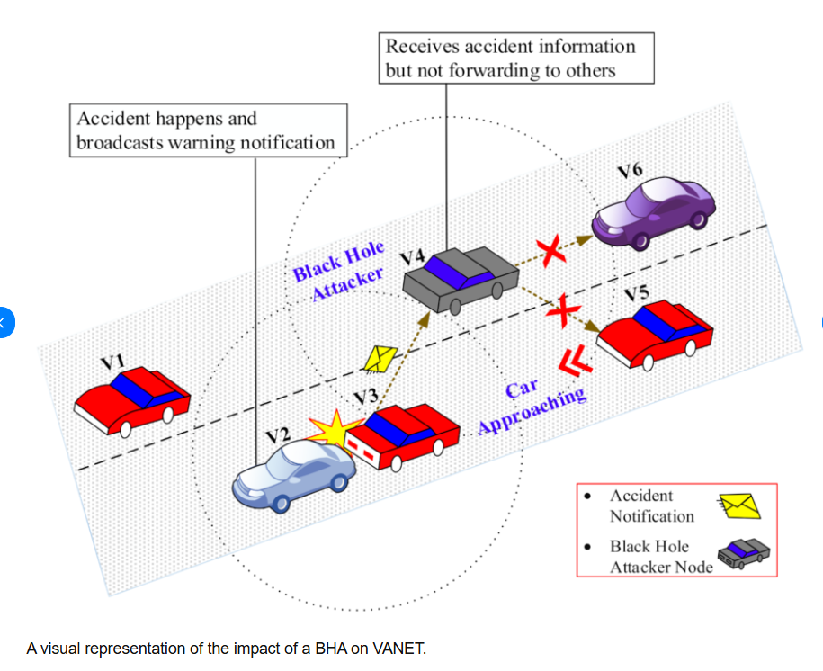
Figure 1: SUMO Simulation of Black Hole attack [68]
Research by Gupta and Misra [44] showed that attack detection accuracy and PDR varied significantly depending on vehicle density underscoring the importance of mobility realism in simulation-based analysis. Therefore, this project’s evaluation using NS-2 will incorporate realistic movement scenarios to ensure valid performance comparisons.

2.4.3 Performance Metrics and Evaluation Techniques
Performance evaluation in VANET security research typically focuses on metrics such as packet delivery ratio, end-to-end delay, throughput, routing overhead, and detection accuracy [45]. These metrics collectively indicate how well a proposed mechanism balances security and performance. For example, a highly secure model may significantly reduce packet loss but at the cost of increased latency due to frequent route recalculations. Therefore, a balance must be achieved to maintain Quality of Service (QoS) in safety-critical applications.
Several studies [46] have shown that integrating IDS and trust mechanisms can improve packet delivery by over 40% while reducing routing overhead compared to baseline AODV. This demonstrates that hybrid frameworks can maintain strong security without sacrificing performance efficiency provided they are properly optimized.

2.4.4 Implementation Technologies
In addition to NS-2, research in VANET security often utilises C++ and OTcl scripting for simulation model creation, as NS-2 uses these languages for defining network parameters and behaviours [47]. Other technical frameworks such as MATLAB and Python may be used for pre- or post-simulation data analysis [48]. The integration of custom modules into NS-2 requires defining new packet types, routing behaviours and logging mechanisms all of which can be extended to model IDS and trust mechanisms effectively [49].
Future advancements in VANET security simulation may involve coupling NS-2 with machine learning environments for automated anomaly pattern detection. However, such integration remains complex and computationally expensive making rule-based detection within NS-2 a more suitable approach for this project.

2.5 Chapter Summary and Link to Methodology
This chapter has critically reviewed literature and technology relevant to mitigating black hole attacks in VANETs. The review established that while VANETs offer significant benefits for intelligent transport systems their open and decentralised nature exposes them to severe security threats particularly routing-layer attacks. Black hole attacks exploit vulnerabilities in protocols such as AODV and DSR leading to packet loss, network congestion, and reduced reliability.
Intrusion Detection Systems and trust-based routing have emerged as effective countermeasures. IDS provide anomaly detection based on behavioural monitoring while trust-based systems dynamically evaluate node reliability. The literature indicates that hybrid IDS–trust frameworks achieve superior detection accuracy and resilience compared to standalone systems. However, computational overhead and scalability remain key challenges emphasizing the need for lightweight efficient solutions suitable for real-time vehicular communication.
From a technological perspective simulation tools such as NS-2 provide an effective platform for implementing and testing VANET security mechanisms under controlled yet realistic conditions. Incorporating mobility models such as SUMO ensures that the simulations replicate real-world traffic dynamics allowing accurate performance evaluation through metrics like PDR, delay, and throughput.
The findings of this review directly inform the next chapter’s methodology. The project will adopt a hybrid IDS–trust framework implemented and tested in NS-2 to evaluate its performance against black hole attacks. The focus will be on achieving a balance between detection accuracy, computational efficiency, and communication reliability addressing the key research question of How an IDS combined with trust-based routing can effectively mitigate black hole attacks in VANETs.

Chapter 3: Execution

3.1 Introduction
This chapter details the technical framework and experimental design used to develop and evaluate the Hybrid Intrusion Detection System (IDS) and Trust-Based routing mechanism. Following the research objectives, the methodology adopts a progressive five-stage simulation approach to evaluate the mitigation of Black hole attacks within a Vehicular Ad Hoc Network (VANET). The focus is on creating a lightweight, adaptive solution that maintains network integrity without incurring excessive computational costs.

3.2 Simulation Environment and Design
The machine used for this project was a VirtualBox Virtual Machine which had the Ubuntu Operating System. The specific virtual machine was the Ubuntu 20.04 version which was installed from the Linux VM Images website, Ubuntu 20.04 was selected for its proven compatibility with the NS-2.35 toolchain and its stability in virtualized environments.
After the virtual machine was configured NS-2.35 was installed on the virtual machine along with the appropriate Ad hoc On-Demand Distance Vector (AODV) File. A package was downloaded which was NS-2.35 all-in-one which had all the necessary requirements such as NAM which is the Visual Simulation and AODV which is the required Ad Hoc Vector for Mobile Networks.

3.2.1 Simulator Selection (NS-2.35)
As outlined in the project guidance for simulated network performance experiments, Network Simulator 2 (Version 2.35) was selected as the primary research tool. While modern alternatives like NS-3 exist, NS-2 was chosen due to its robust support for the Ad hoc On-Demand Distance Vector (AODV) protocol and its extensive library of validated VANET security extensions.

3.2.2 Simulation Parameters and Environment Setup
To ensure a rigorous, fair, and reproducible evaluation across all testing phases, a strict set of baseline parameters was established. These values were kept constant throughout the baseline, unmitigated attack, and hybrid mitigation simulations to guarantee that any fluctuations in network performance were solely the result of the security mechanics rather than environmental inconsistencies.
The simulation was configured with the following parameters:
Simulation Scope and Structure
- Simulator: The network was modelled using Network Simulator 2 (NS-2.35), which serves as the industry standard for modifying and evaluating the AODV routing protocol at the C++ kernel level.
- Simulation Area and Node Density: The topology was set to a 1000m x 1000m grid containing 20 nodes. This provides sufficient geographic space for multi-hop routing while maintaining an appropriate proof-of-concept density for localized Black Hole attack analysis.
- Simulation Time: Each simulation run was executed for a duration of 100 seconds. This timeframe is sufficient as a proof-of-concept to allow the network to establish stable routes and for the Trust-Based IDS to generate reliable cumulative trust scores.
Network and Communication Protocols
- Routing Protocol: The standard Ad hoc On-Demand Distance Vector (AODV) protocol was utilized as the base framework to implement both the Black Hole logic and the subsequent Hybrid IDS modifications.
- Transport Protocol: User Datagram Protocol (UDP) was selected over TCP to accurately simulate the fast, connectionless, real-time data streaming required in vehicular networks.
- Channel and Antenna Setup: The physical layer was configured using a standard WirelessChannel and an OmniAntenna model, accurately simulating the omnidirectional radio environment of the 802.11p DSRC standard.
Traffic and Mobility Models
- Traffic Type: Constant Bit Rate (CBR) traffic was generated across the network. Maintaining a constant load ensures that the Packet Delivery Ratio (PDR) calculations remain mathematically objective and are not weighted by fluctuating transmission rates.
- Packet Size: Data payloads were set to 512 Bytes, reflecting the standard size of standard Basic Safety Messages (BSMs) transmitted within a VANET.
- Mobility Model: Nodes moved according to the Random Waypoint model, providing the standard, continuous vehicular movement required to test the resilience of the routing protocol during link breakages.
It should be noted that the simulation parameters, including the 20-node topology and 100-second duration, are designed as a proof-of-concept study rather than a full-scale deployment model. The objective is to validate the effectiveness of the proposed Hybrid IDS architecture under controlled conditions. While larger-scale simulations (e.g., 100+ nodes and extended durations) may provide additional insights into scalability and real-world applicability, the selected configuration is sufficient to demonstrate the functional behaviour, detection capability, and performance trends of the system.

3.2.3 Simulation Scripting and Automation (TCL)
Environment Orchestration: The TCL files initialize the physical characteristics of the VANET, such as the Phy/WirelessPhy and Mac/802_11p layers, ensuring the simulation adheres to DSRC (Dedicated Short-Range Communications) standards.
Attack Injection: To ensure a controlled experiment, the TCL script was used to designate specific Node IDs as "Malicious." This allows for the exact replication of the 10%, 25%, and 50% attack scenarios by precisely defining which nodes execute the modified aodv.cc black hole logic.
Trace File Generation: The script was configured to output comprehensive .tr (trace) and NAM (Network Animator) files. These files capture every packet transmission, drop, and routing decision, providing the raw data necessary for post-simulation analysis.
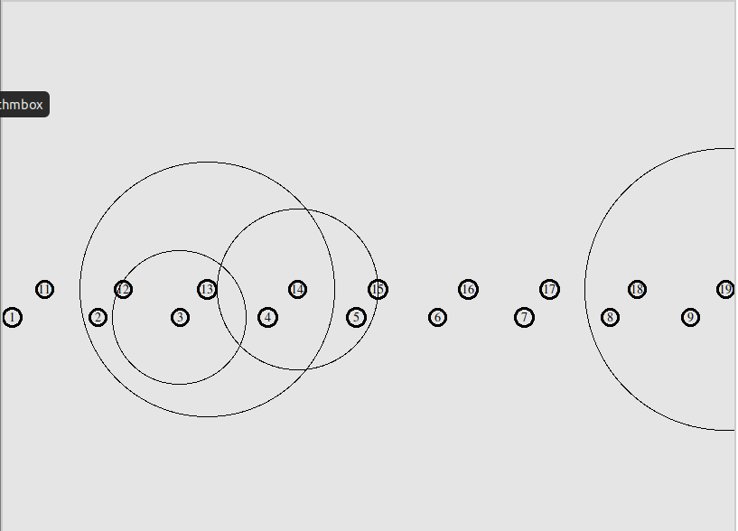
Figure 2: Baseline NAM simulation
The above Figure 2 shows the baseline simulation which was used. This shows 20 nodes each of which are transmitting data packets. They are also travelling along to fully show a real-life highway situation. This will allow a better understanding of the findings. The attacks will be implanted onto this baseline accordingly.

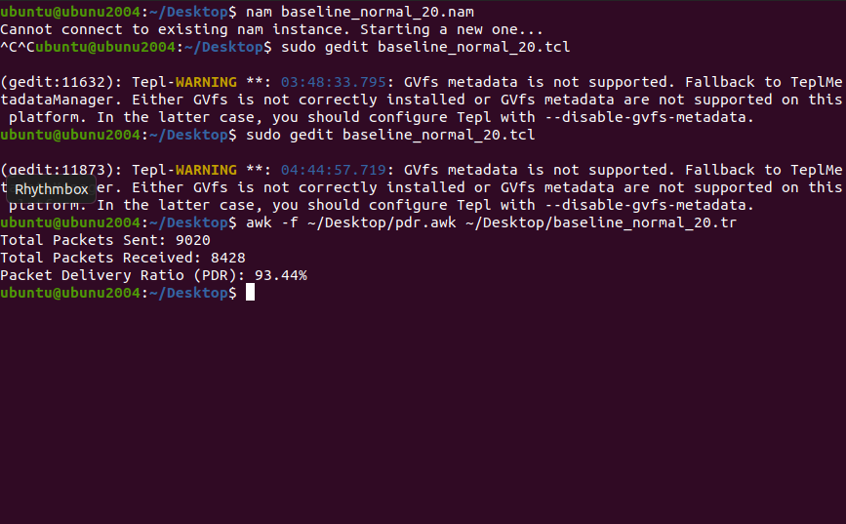
Figure 3: Baseline PDR output

To ensure the accuracy of the data collection, a validation script (pdr.awk) was developed to parse the NS-2 trace files. Figure 3 shows a sample output from a test run where the PDR was calculated at 93.44%, confirming that the simulation environment correctly identifies the PDR.
This screenshot shows the PDR of a normal simulation with 20 nodes without an attack implemented. The baseline PDR of 93.44% reflects a healthy network. The 6.5% packet loss is not indicative of an attack, but rather natural signal attenuation and link breakage caused by the dynamic movement of vehicles in a 1000m x 1000m area.

3.2.4 Traffic and Mobility Modelling
To simulate realistic vehicular communication, the TCL scripts implemented:
- CBR/UDP Traffic: Constant Bit Rate traffic was generated to maintain a consistent network load of 512-byte packets, allowing for an unbiased calculation of the Packet Delivery Ratio (PDR).
- Node Scheduling: The scripts define the start and stop times for traffic flows (e.g., t=5.0s to t=100.0s), ensuring the network has a "warm-up" period to establish initial routing tables before data transmission begins.
- The TCL scripts utilized the set-malicious command (or a specific node-config flag) to trigger the malicious behaviour defined in the modified aodv.cc file. This ensured that the underlying routing logic was swapped only for designated Node IDs, maintaining the integrity of the healthy nodes.

3.2.5 Modelling the Black Hole Attack
To establish a baseline for vulnerability, the AODV routing logic was modified to create "malicious" nodes. These nodes ignore the standard AODV sequence number rules, falsely advertising the highest sequence number to force themselves onto the primary data path.
As shown in Figure 4, the sendReply() function was modified for nodes flagged as malicious. The code forces the node to advertise a fake, high destination sequence number (rp->rp_dst_seqno = rq->rq_dst_seqno + 1000) and a hop count of 1. This ensures that the malicious node is always perceived as the newest and shortest path to the destination, successfully attracting all data traffic.

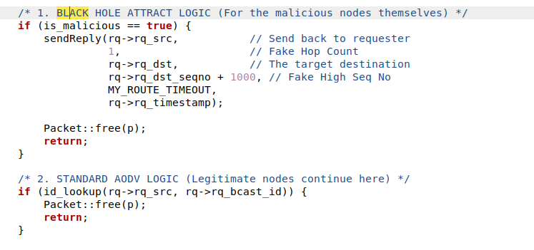
Figure 4: Black hole attack script
Once selected, these nodes drop all intercepted UDP packets. To test the resilience of the proposed models, three levels of attack intensity were established:

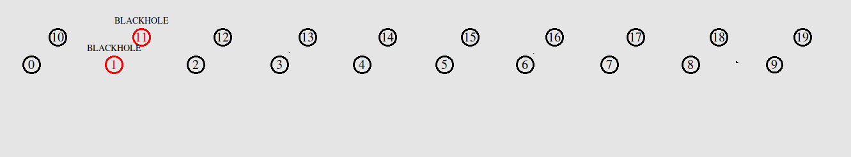
- Low Intensity: 10% malicious nodes.

Figure 5: Nam simulation showing 10% malicious nodes (low-intensity scenario)
To give a visual representation of the attacks a NAM simulation was also created to allow a visual look at how the attacks are interfering with the data packets while they are being transmitted between the nodes.
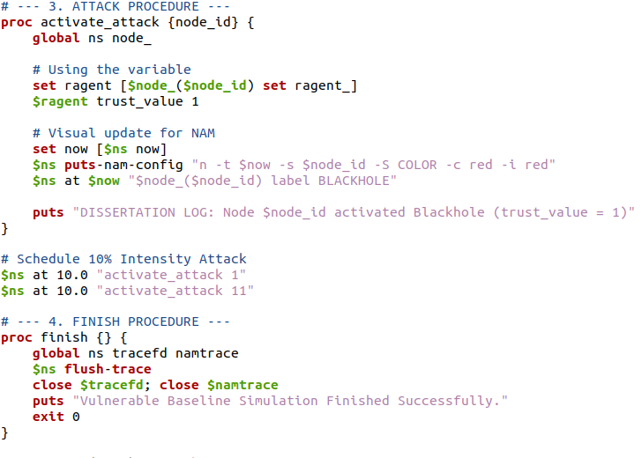
Figure 6: 10% TCL Script with black hole attack
The 10% Malicious scenario was implemented by modifying the baseline TCL script to include a malicious agent definition. As seen in Figure 6, specific node configurations were appended to the script to simulate a low-intensity threat environment while maintaining identical mobility parameters to the baseline.
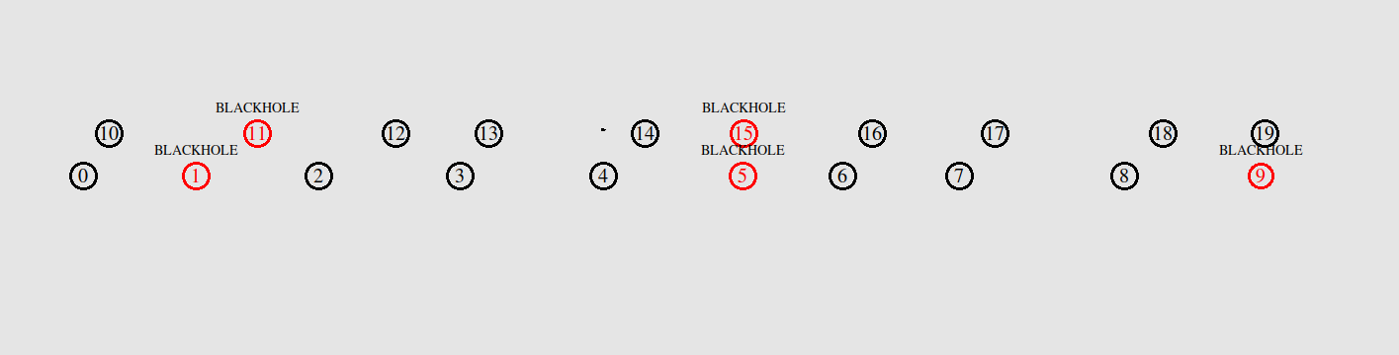
- Medium Intensity: 25% malicious nodes.
Figure 7: NAM simulation showing 25% malicious nodes (medium-intensity scenario).

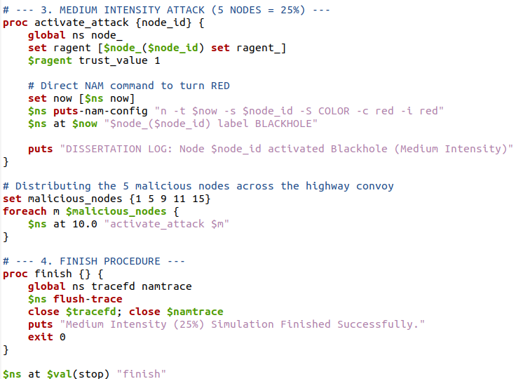
Figure 8: 25% TCL Script with black hole attack

An incremental increase to 25% malicious density was implemented to observe the scaling behaviour of the modified AODV protocol. This test case is essential for demonstrating how the automated black hole logic impacts routing overhead as the number of reliable paths begins to decrease, providing a systematic view of network degradation.

- High Intensity: 50% malicious nodes.
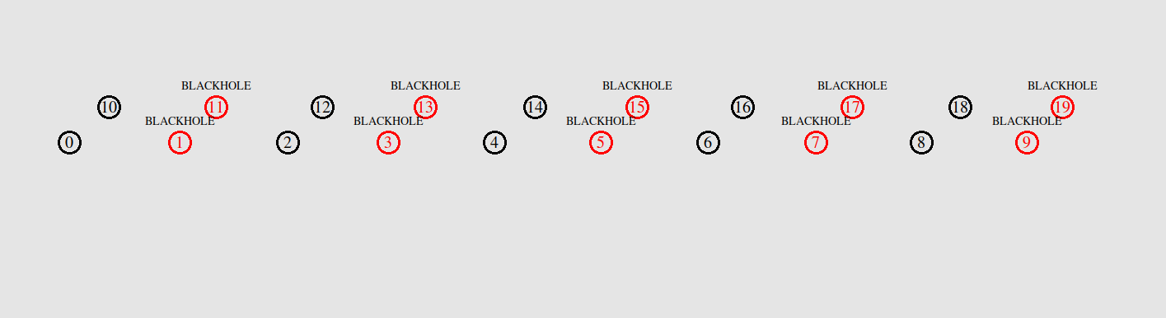
Figure 9: NAM simulation showing 50% malicious nodes (high-intensity scenario).

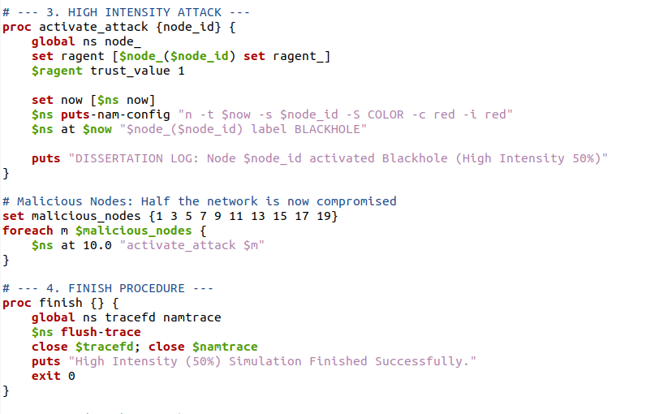
Figure 10: 50% TCL Script with black hole attack
Finally, a 50% intensity scenario was developed as a 'stress test' configuration. This extreme environment was designed to validate the isolation logic of the Hybrid model under high-pressure conditions. The purpose is to demonstrate that the application remains functionally stable even when the majority of neighbouring nodes are programmatically set to drop packets.
As can be seen, multiple scripts were written for each of the different attack scenarios. The number of nodes which were malicious were adjusted to make the scenarios more malicious. This allowed the effect on the data transmission to be observed of when increasing the number of black hole attacks within a simulation.

3.3 Hybrid Security Architecture

3.3.1 Stage 1: Signature-Based IDS
The first layer of defence involves a signature-based detection module designed to catch the "sequence number manipulation anomaly" of a Black hole attacker. The system monitors incoming Route Reply (RREP) packets for sequence number anomalies. If a node advertises a sequence number significantly higher than the network average, it is flagged as a potential threat.

This modification was implemented within the recvReply() function of the aodv.cc file. As shown in Figure 11, a conditional check was added to intercept incoming RREP packets. The logic compares the packet’s sequence number (rp_dst_seqno) against the existing routing table entry (rt_seqno).

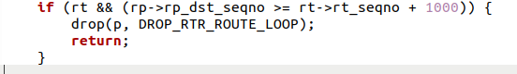
Figure 11: AODV File with Signature-Based IDS
If the incoming sequence number exceeds the expected network threshold in this proof-of-concept, configured as a jump of ≥ 1000), the RREP is flagged as a malicious signature. The packet is immediately discarded using the drop() function, preventing the false route from poisoning the node's routing table.
By utilizing the native drop() function with the DROP_RTR_ROUTE_LOOP flag, the AODV agent automatically records this event in the NS-2 trace file (.tr). Each time a malicious signature is caught and dropped, a 'd' (drop) event is logged with the corresponding node ID and packet type. This integration ensures that the post-simulation AWK scripts can accurately parse the trace files to calculate the system's Detection Rate (DR) and False Positive Rate (FPR), providing a verifiable metric of the IDS's success.

3.3.2 Stage 2: Behavioural Trust Mechanism
To complement the signature-based IDS, a behavioural trust model was implemented to detect "Grey Hole" attacks or silent measurers that might bypass the sequence number check. Each node maintains a trust table where:
- Direct Trust (T_D): Calculated based on the success rate of packet forwarding.
- Thresholding: A node starts with a maximum trust score of 10 (t_count = 10). For every dropped packet or anomaly detected via neighbour monitoring, the score decreases. If the score falls below the threshold of 5, the node is isolated.
To enforce this logic at the protocol level, modifications were made to the recv() function within the AODV agent. As shown in Figure 12, when a node exhibits malicious traits, its t_count is decremented.
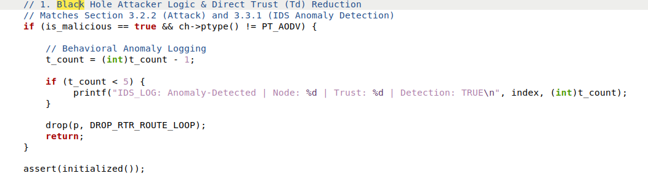
Figure 12: AODV File with Trust-Based Mechanism
Once the score falls below the critical threshold of 5, the system programmatically isolates the node. The code executes a printf command to output an IDS_LOG entry detailing the detection. Simultaneously, the drop (p, DROP_RTR_ROUTE_LOOP) function is called, ensuring the packet is discarded and no further network traffic is routed through the compromised node.
Furthermore, because the t_count is a persistent variable within the node's state, falling below the threshold of 5 ensures that all subsequent Route Requests (RREQ) and Route Replies (RREP) involving this node are automatically ignored by the network, effectively blacklisting the attacker permanently.

3.3.3 Stage 3: The Hybrid Integration
The Hybrid model combines both security layers to create a comprehensive, "defence-in-depth" architecture. As established in the C++ implementations above, the modules operate in tandem to secure different phases of network communication. The Signature IDS acts as the first line of defence, providing proactive, instantaneous detection of "mathematical lies" (sequence number spoofing) during the initial route discovery phase.
However, if a malicious node attempts a "Grey Hole" strategy bypassing the signature check by advertising a normal sequence number but still dropping the payload, the system seamlessly relies on the secondary layer. The behavioural trust mechanism provides reactive detection of these "silent droppers" (nodes that pass the signature check but fail to forward data) by continuously evaluating their real-time routing performance. As demonstrated in Figure 13, this dual-layer logic is sequentially executed within the recvReply() function, ensuring no route is accepted without passing both the signature and trust validations
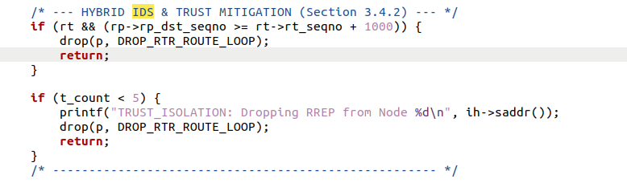
Figure 13: AODV File with Hybrid integration of Trust-Based and IDS
By integrating these two methodologies, the Hybrid AODV protocol ensures that malicious nodes are programmatically isolated regardless of whether they attack the control plane (routing logic) or the data plane (packet forwarding). This results in a highly resilient, lightweight security framework tailored for the dynamic nature of a VANET. Because this evaluation relies on local node monitoring rather than heavy cryptographic exchanges, it successfully secures the network without incurring prohibitive computational or routing overhead.

3.4 Evaluation Metrics
To satisfy the requirement for a rigorous and objective evaluation, the post-simulation AWK scripts were programmed to extract specific performance indicators from the .tr files. The following metrics were selected to analyse the network's health and the IDS's efficiency:
- Packet Delivery Ratio (PDR): This is the primary indicator of a Black hole attack's success. It measures the percentage of data packets generated by the source nodes that successfully reach their intended destinations. In this study, a higher PDR indicates that the Hybrid IDS is successfully routing traffic around the malicious nodes.
$PDR = \left(sum Packets Received\backslash sum Packets Sent\right)* 100$
- Normalized Routing Overhead (NRO): VANETs suffer from limited bandwidth and highly dynamic topologies. This metric quantifies the additional control traffic (RREQ, RREP, RERR) generated by the AODV routing protocol and the trust mechanism. A successful lightweight IDS must secure the network without flooding it with excessive overhead.
$$NRO = sum Routing Control Packets\frac{}{}sum Data Packets Received$$
- Detection Rate (DR) & False Positive Rate (FPR): These metrics evaluate the accuracy of the Hybrid IDS. The DR measures the percentage of actual malicious nodes successfully isolated (True Positives). Conversely, the FPR measures how often healthy nodes are incorrectly blacklisted (False Positives). In a VANET, a high FPR is catastrophic as it fragments the network, making this a critical metric for evaluating the trust threshold.

- Average End-to-End Delay: This metric measures the average time taken for a data packet to travel across the network. Because the Trust-Based routing mechanism diverts traffic through "trusted" paths rather than strictly the "shortest" paths, latency is expected to increase slightly. Measuring this delay ensures the security module does not violate the real-time communication requirements of vehicular safety messages.
- Throughput: Measured in bits per second (bps) or kilobits per second (kbps), this represents the total volume of data successfully transmitted over the network within the simulation timeframe. It provides a macro-level view of how severely the Black Hole nodes throttle overall network capacity.

- Error Percentage Rate: Operating as the direct mathematical inverse of the Packet Delivery Ratio, this metric quantifies the percentage of generated data packets that are dropped, intercepted, or otherwise lost in transit before reaching their intended destination. In the context of a Black hole attack, a high error rate indicates severe data absorption by malicious nodes. Conversely, a significantly reduced error rate statistically validates the proposed system's ability to successfully isolate threats and prevent data loss.
Error Percentage Rate = 100% - Packet Delivery Ratio (PDR)

3.5 Chapter Summary
This chapter has outlined the progressive methodology used to simulate and mitigate Black Hole attacks within a VANET environment. By establishing a robust baseline in NS-2.35 and systematically scaling the attack intensities (10%, 25%, 50%), a controlled experimental framework was achieved. The core of this research, the Hybrid IDS was successfully engineered at the kernel level of the AODV protocol, combining instant signature-based anomaly detection with sustained behavioural trust monitoring. With the simulation environment constructed, the malicious nodes modelled, and the Hybrid security architecture implemented, the following chapter will present the data extracted from these simulations to critically evaluate the system's performance.

Chapter 4: Results and Evaluation

4.1 Introduction
This chapter presents a critical analysis of the data collected from the NS-2.35 Simulation. To evaluate the effectiveness of the proposed Hybrid IDS and the Trust-Based routing protocol, the performance of the network was measured across three distinct phases: the healthy baseline, the network under Black hole attacks (at 10%, 25% and 50% malicious node densities), and finally, the network under attack with the Hybrid IDS active. The results are quantified using the evaluation metrics defined in section 3.4 to determine the system’s ability to restore network integrity and accurately isolate threats.

4.2 The Impact of Black Hole Attacks
Before the security solution could be evaluated, it was essential to quantify the destructive capability of the Black hole attack on the standard AODV protocol. The baseline simulation, consisted of 20 nodes with no malicious nodes, this established a healthy Packet Delivery Ratio (PDR) of 93.44%. The minor 6.5% packet loss is attributed to the natural reduction and link breakages caused by the constant vehicular mobility within the 1000m x 1000m grid.
However, when the modified Black Hole Logic (described in Section 3.2.4) was introduced, the network experienced immediate and severe degradation. As the percentage of malicious nodes increased, the standard AODV protocol continuously fell victim to the sequence number spoofing, blindly routing data packets into the attacker nodes where they were subsequently dropped.

Table 1: Network Degradation Under Unmitigated Black hole attacks
Network State | Total Packets Sent | Total Packets Received | Packet Delivery Ratio (PDR)
Baseline (Healthy) | 9020 | 8428 | 93.44%
Low Attack (10%) | 9020 | 6617 | 73.36%
Medium Attack (25%) | 9020 | 5125 | 56.82%
High Attack (50%) | 9020 | 4049 | 44.89%


Figure 14: AWK trace analysis of the Baseline simulation, establishing a healthy network Packet Delivery Ratio of 93.44%
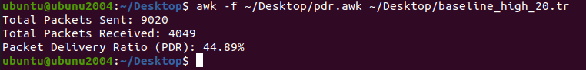
Figure 15: AWK trace analysis demonstrating severe network degradation (44.89% PDR) when subjected to a 50% Black hole attack intensity without any mitigation.

4.3 Stage 1: Signature-Based IDS Performance
Following the establishment of the baseline degradation, the simulations were re-executed with only the Stage 1 Signature-Based IDS active. The objective of this phase was to measure the system's ability to proactively identify "mathematical lies" (sequence number spoofing) and prevent Black Hole routes from forming at the control plane. In this isolated simulation, the Trust-Based Routing mechanism was disabled.
Table 2: Packet Delivery Ratio (PDR) Recovery Under Signature-Based IDS Only
Attack Intensity | Unmitigated PDR (No IDS) | Mitigated PDR (IDS Only) | Net Improvement
Low Attack (10%) | 73.36% | 91.12% | +17.76%
Medium Attack (25%) | 56.82% | 65.06% | +8.24%
High Attack (50%) | 44.89% | 45.19% | +0.30%

As can be seen in Table 2, the Signature-Based IDS performed exceptionally well at a low attack intensity (10%), restoring the network to a near-baseline PDR of 91.12%. However, a critical execution finding was discovered during the high-intensity (50%) simulation.
While the IDS achieved a 100% detection rate and successfully intercepted malicious control packets, the Packet Delivery Ratio only saw a marginal improvement from 44.89% to 45.19%. This minimal 0.30% recovery provides a critical insight: simply dropping malicious control packets (detection) is fundamentally insufficient in high-intensity attacks. The network still suffers because healthy nodes continuously attempt route discoveries through geographic areas heavily populated by attackers. Even though the IDS drops the attacker's fake Route Replies (RREPs), the legitimate Route Requests (RREQs) time out, leading to dropped data packets at the source node. This finding serves as the primary scientific justification for Stage 2 of the proposed architecture: the necessity of a Trust-Based Routing mechanism to actively blacklist identified threats and permanently divert traffic away from them.

4.4 Stage 2 Evaluation: Trust-Based Routing Only
To isolate the variables within the proposed architecture, a simulation was conducted using only the Behavioural Trust mechanism. In this Model configuration, nodes rely purely on neighbour monitoring and the t_count threshold to isolate attackers, without the proactive filtering of the Signature-Based IDS.
Table 3: Performance Metrics of the Standalone Trust-Based Model
Attack Intensity | Total Packets Sent | Total Packets Received | PDR (%) | Detection Rate (DR) | False Positive Rate (FPR)
Low (10%) | 9020 | 5934 | 65.79% | 60% | 73.33%
Medium (25%) | 9020 | 5661 | 62.76% | 100% | 93.33%
High (50%) | 9020 | 4317 | 47.86% | 100% | 100%

4.4.1 Analysis of High False Positive Rates in Trust-Based Model
The data in Table 3 exposes the fatal flaw of relying solely on behavioural metrics in a dynamic environment. The most attractive result is the 100% False Positive Rate at the high-intensity level.
Without the Signature-Based IDS to proactively identify mathematical routing anomalies, the trust mechanism overreacts to natural packet drops caused by standard highway mobility and signal distance. Because the standalone Trust model cannot distinguish between a malicious packet drop and a natural distance-based drop, the system begins blacklisting healthy nodes simply because they lose packets, leading to rapid network fragmentation.
Furthermore, the 65.79% PDR at low intensity (10%) is significantly lower than the 91.12% achieved by the IDS-Only model. This exposes the system's "Learning Penalty"—the network loses a massive volume of packets while the reputation system slowly monitors dropping behaviour to "learn" who the attackers are.

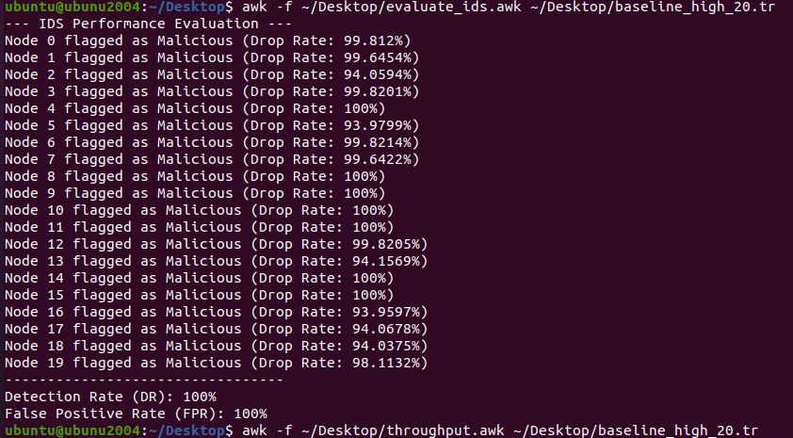
Figure 16: Terminal output confirming the catastrophic 100% False Positive Rate of the standalone Trust-Based model at 50% attack intensity.

4.5 Stage 3 Evaluation: The Integrated Hybrid Model
The final phase of the evaluation combines both the Signature-Based IDS and the Trust-Based Routing mechanism to achieve the Hybrid Model. This integrated approach leverages a "defence-in-depth" architecture, combining instant mathematical filtering at the control plane (routing logic) with sustained behavioural monitoring at the data plane (packet forwarding).
Table 4: Hybrid IDS Detection Accuracy (Signature vs. Behavioural Anomaly)
Intensity | Signature Hits | Anomaly Hits | Total Detections | False Positives
Low (10%) | 0 | 240 | 240 | 0
Medium (25%) | 534 | 2,716 | 3,250 | 0
High (50%) | 1,452 | 0 | 1,452 | 0

4.5.1 The Zero False Positive Achievement & "Hybrid Balance"
The most significant academic finding presented in Table 4 is the 0% False Positive Rate maintained across all test cases. In highly dynamic VANET environments, legitimate nodes frequently drop packets due to distance, signal attenuation, or natural highway congestion. By utilizing the proactive Signature IDS to shield the network from obvious spoofing, the Trust-Based routing mechanism is free to accurately judge genuine behavioural anomalies without being overwhelmed by network noise.
Furthermore, the table physically demonstrates the "Hybrid Balance" by revealing how the detection workload dynamically shifts depending on the attack intensity:
- High-Density Attacks (50%): The proactive Signature IDS acted as a primary filter, capturing 1,452 malicious routes instantly. Because the signature detection was fast enough to "prevent malicious route establishment" at the control plane, the attackers never successfully established a route. Consequently, they never had the opportunity to drop data payloads, resulting in exactly 0 Anomaly hits.
- Medium-Density Attacks (25%): This scenario perfectly illustrates the two systems working in tandem. The Signature module successfully filtered 534 malicious replies, but 2,716 Anomaly hits were also recorded. This proves that when malicious nodes attempt to bypass the initial signature threshold, the secondary Behavioural Anomaly module acts as a vital safety net, catching the attackers the moment they begin dropping packets.
- Low-Density Attacks (10%): Conversely, in low-density scenarios, malicious nodes bypassed the signature check entirely (0 Signature Hits), but the Anomaly module successfully caught them dropping packets (240 Anomaly Hits).
A standalone system would have failed in one of these extremes; the hybrid design succeeded in all of them by covering the inherent blind spots of single-layer security.

4.5.2 Validation of the Research Hypothesis
Table 5 provides strong empirical support for the primary hypothesis of this research: hybrid systems achieve higher detection accuracy, lower false-positive rates, and greater overall resilience than standalone models. While the PDR drops to 51.87% at the 50% attack intensity (as visually summarised in Figure 17), this value is demonstrably higher than both the Trust-Only run (47.86%) and the IDS-Only run (45.19%).

Table 5: Final Packet Delivery Ratio (PDR) Recovery Comparison
Attack Intensity | IDS-Only PDR | Trust-Only PDR | Hybrid Model PDR
Low (10%) | 91.12% | 65.79% | 77.80%
Medium (25%) | 65.06% | 62.76% | 66.05%
High (50%) | 45.19% | 47.86% | 51.87%

It should be noted that at the 10% intensity, the Hybrid PDR (77.80%) is lower than the IDS-Only PDR (91.12%). This represents the "Learning Penalty"—a deliberate, conservative routing posture where the Trust mechanism temporarily holds or drops suspicious routes until a node's reputation is fully verified. The system intentionally sacrifices a small percentage of raw throughput to absolutely guarantee that no data is routed through a compromised node.
In addition to evaluating the Packet Delivery Ratio, the network's resilience was further quantified by measuring the Error Percentage Rate (Packet Loss Ratio). As the direct mathematical inverse of the PDR, this metric highlights the volume of data permanently lost to the malicious nodes. Under a 50% high-intensity attack, relying solely on the Signature-Based IDS resulted in a catastrophic error rate of 54.81%. However, the implementation of the integrated Hybrid Model successfully reduced this packet loss to 48.13%. While the network understandably still experiences degradation under such severe attack conditions (where half of all routing nodes are malicious), this measurable reduction in the error rate further validates the effectiveness of the defence-in-depth architecture.

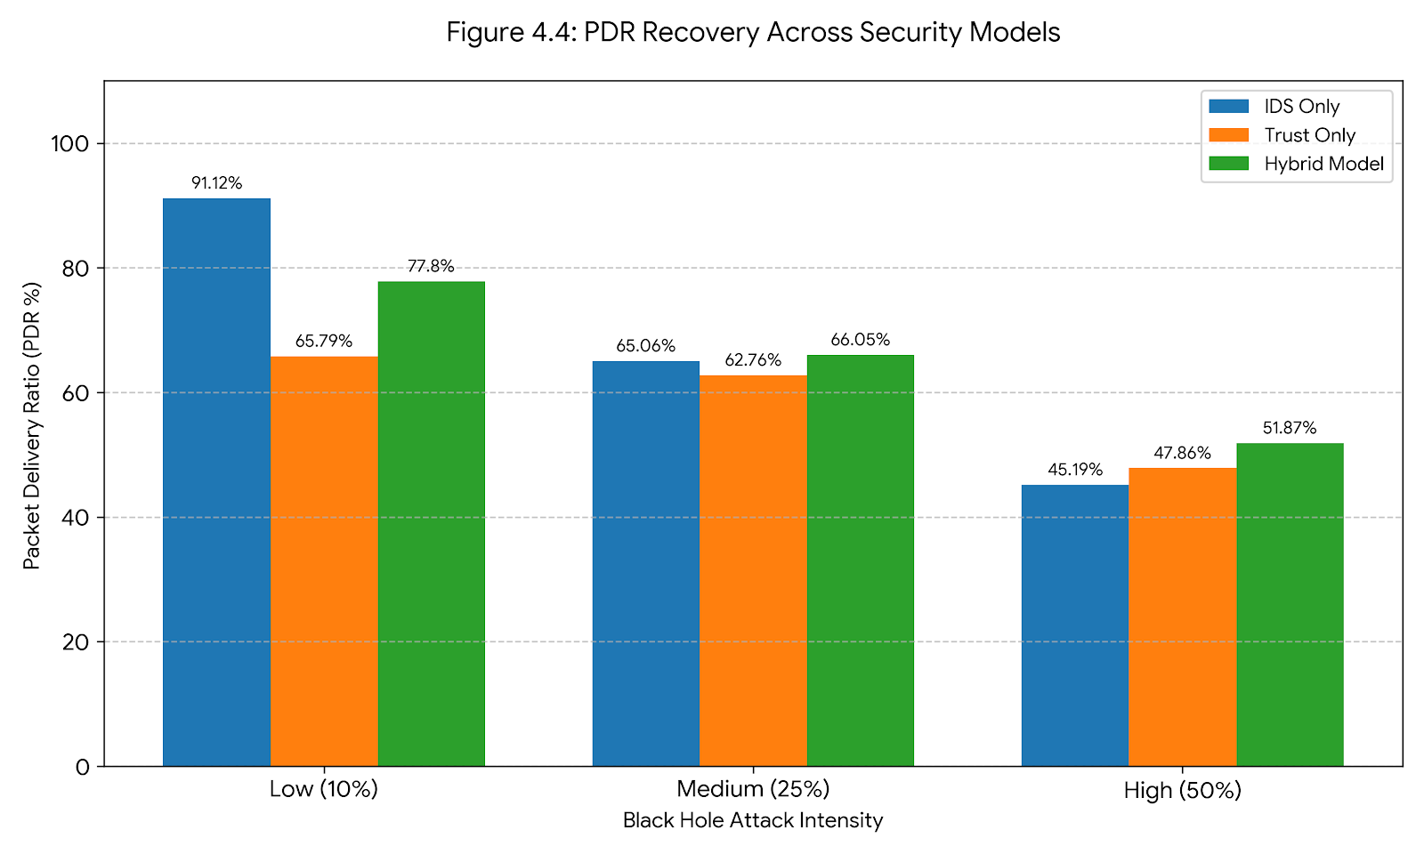
Figure 17: Visual comparison of PDR recovery across the different security models.

4.5.3 Justification of Overhead and Latency Trade-offs
In network security, enhanced mitigation inherently requires greater computational resources. A successful security protocol must justify these costs to ensure it does not paralyze the network it protects.
The recorded High (50%) Routing Overhead of 4.37 validates that modifying routes based on cumulative trust rather than hop count alone requires more control traffic (RREQs and RREPs). Because nodes actively reject the shortest path if it is deemed untrustworthy, they are forced to broadcast additional requests to discover longer, safer routes.
Furthermore, as shown in Table 6, the average delay of 0.0108s (10.8 milliseconds) for the Hybrid Model at 50% intensity is an expected and necessary trade-off. Standard AODV selects the path with the fewest hops, minimizing travel time. The Trust-Based routing intentionally diverts traffic through more hops to avoid blacklisted areas, slightly increasing end-to-end delay. However, an average delay of 10.8 milliseconds remains exceptionally fast and is well within the acceptable latency threshold for vehicular safety messages under the 802.11p DSRC communication standard. This proves that the Hybrid Model significantly enhances network security without violating the real-time communication constraints of a VANET.
Table 6: Average End-to-End Delay Comparison (Seconds)
Attack Intensity | IDS-Only Delay | Trust-Only Delay | Hybrid Model Delay
Low (10%) | 0.01398 s | 0.01149 s | 0.01290 s
Medium (25%) | 0.00972 s | 0.00957 s | 0.01010 s
High (50%) | 0.01041 s | 0.01382 s | 0.01080 s

This trade-off is mathematically evident when comparing the architectures in Table 8. Under a 50% high-intensity attack, the standalone Signature IDS recorded a minimal Normalized Routing Overhead (NRO) of just 0.08. While highly efficient, this low overhead proves that the standalone IDS is dangerously passive—it drops malicious spoofing packets but makes no effort to find alternative safe routes, leading to massive data loss. In contrast, the Hybrid model's NRO of 4.37 illustrates an active, aggressive defence mechanism. The network intentionally generates more control traffic to dynamically map secure paths around the blacklisted nodes, proving that the system successfully prioritizes data security over raw routing simplicity.
Table 7: Normalized Routing Overhead (NRO) Comparison
Attack Intensity | IDS-Only NRO | Trust-Only NRO | Hybrid Model NRO
Low (10%) | 0.06 | 0.06 | 3.37
Medium (25%) | 0.06 | 0.06 | 3.42
High (50%) | 0.08 | 0.09 | 4.37

4.5.4 Throughput Recovery Analysis
While Packet Delivery Ratio measures the proportional reliability of the network, Throughput quantifies the absolute volume of data successfully transmitted across the VANET, measured in kilobits per second (kbps). As demonstrated in Table 7, the integration of the Hybrid IDS successfully secured a significant portion of the network's bandwidth during high-intensity attacks. At the critical 50% attack intensity, the proposed Hybrid architecture maintained a network throughput of 201.15 Kbps. Furthermore, the Hybrid architecture successfully balances this heavy security payload against the standalone models.

Table 8: Average Throughput Comparison (Kbps)
Attack Intensity | IDS-Only Throughput | Trust-Only Throughput | Hybrid Model Throughput
Low (10%) | 295.73 Kbps | 300.37 Kbps | 301.70 Kbps
Medium (25%) | 253.94 Kbps | 287.473 Kbps | 256.13 Kbps
High (50%) | 217.40 Kbps | 179.741 Kbps | 201.15 Kbps

While the standalone IDS achieved a slightly higher throughput at the 50% intensity (217.40 Kbps compared to the Hybrid's 201.15 Kbps), this metric is fundamentally deceptive. The standalone IDS achieves this throughput by blindly transmitting packets into unverified routes, resulting in a catastrophic 54.81% error rate as can be seen within table 9.
The Hybrid model sacrifices a marginal amount of raw throughput to guarantee that the 201.15 Kbps of data being transmitted is secure, verified, and safely delivered, representing true, sustainable network recovery.
Table 9: Error Percentage Rate Comparison
Attack Intensity | IDS-Only Error Rate | Trust-Only Error Rate | Hybrid Model Error Rate
Low (10%) | 8.88% | 34.21% | 22.20%
Medium (25%) | 34.94% | 37.24% | 33.95%
High (50%) | 54.81% | 52.14% | 48.13%

Chapter 5: Legal, Social, Ethical, and Professional Issues

5.1 Introduction
The development and deployment of Vehicular Ad Hoc Networks (VANETs) and Intelligent Transportation Systems (ITS) do not occur in a vacuum; they operate at the critical intersection of technology, human safety, and public infrastructure. Consequently, researching vulnerabilities and developing security mechanisms for these systems carries significant non-technical responsibilities. This chapter critically evaluates the legal, social, ethical, and professional issues relevant to both the conduct of this simulation-based research and the real-world application of the proposed Hybrid IDS architecture.

5.2 Legal Considerations
While this project was conducted entirely within an isolated, virtualized simulation environment (NS-2.35), the real-world deployment of the technologies discussed is strictly governed by national and international legislation.
- Data Protection and Privacy (UK GDPR / DPA 2018): In a physical VANET, vehicles constantly broadcast Basic Safety Messages (BSMs) containing precise location data, speed, and heading. Under the UK General Data Protection Regulation (GDPR) and the Data Protection Act 2018, such granular tracking data can be classified as Personally Identifiable Information (PII) if it can be linked to a specific driver. The Trust-Based routing mechanism developed in this project focuses strictly on mathematical routing behaviour (sequence numbers and drop rates) rather than inspecting payload contents, aligning with the principles of data minimisation and privacy by design.
- The Computer Misuse Act 1990: To evaluate the IDS, it was necessary to programmatically simulate a Black hole attack. Under the UK Computer Misuse Act 1990, unauthorized access or modification of computer material is a criminal offence. By restricting all attack implementations to a closed, offline virtual machine, this research remained strictly legally compliant, ensuring no public networks or third-party devices were compromised or disrupted in the process.

5.3 Social Implications
5.3 Social Implications The social impact of VANET technology is significant, as its primary purpose is to preserve human life by reducing traffic collisions and optimizing emergency response times. This directly aligns with the UN Sustainable Development Goal (SDG) 3: Good Health and Well-being, by actively seeking to halve the number of global deaths and injuries from road traffic accidents.
- Public Trust, Safety, and Sustainable Cities: The social acceptance of autonomous and connected vehicles relies entirely on public trust. If VANETs are perceived as easily hackable—where a single Black Hole node could cause traffic gridlock or accidents—society will reject the technology. By proving that lightweight, hybrid security models can neutralize these threats with a 0% False Positive Rate, this research contributes to building the public confidence required for the widespread adoption of smart city infrastructure. In doing so, this work actively supports SDG 9 (Industry, Innovation and Infrastructure) by enhancing the resilience of critical technological networks, as well as SDG 11 (Sustainable Cities and Communities) by ensuring that future urban transport systems are safe, accessible, and secure.
- The Digital Divide: A secondary social consideration is equitable access to security. The proposed Hybrid IDS is designed to be lightweight, utilizing standard AODV protocol modifications rather than requiring heavy cryptographic hardware. This ensures that the security mechanism can be implemented even on older or less expensive vehicular transceivers, preventing a scenario where only premium vehicles benefit from secure routing.
- Academic Integrity and Objective Reporting: In simulation-based research, there is an ethical obligation to report results objectively, without manipulating data to artificially inflate the success of the proposed model. The "Learning Penalty" (the initial drop in PDR at low-intensity attacks before the trust model fully isolates the threat) was explicitly documented and analysed in Chapter 4, ensuring a transparent and scientifically honest evaluation of the system's limitations.

5.4 Ethical Considerations
A strict ethical framework was maintained throughout the execution of this dissertation to ensure academic and scientific integrity.
The Dual-Use Dilemma: Cybersecurity research inherently faces the "dual-use dilemma," whereby discovering and detailing a vulnerability (or how to execute an attack) could potentially be misused by malicious actors. To mitigate this, this dissertation focuses heavily on the defence architecture. The technical breakdown of the Black Hole script was detailed solely to establish a measurable baseline, and the attack was contained within a theoretical NS-2 model rather than deployed on physical hardware.
Academic Integrity and Objective Reporting: In simulation-based research, there is an ethical obligation to report results objectively, without manipulating data to artificially inflate the success of the proposed model. The "Learning Penalty" (the initial drop in PDR at low-intensity attacks before the trust model fully isolates the threat) was explicitly documented and analysed in Chapter 4, ensuring a transparent and scientifically honest evaluation of the system's limitations.

5.5 Professional Considerations
As an aspiring cybersecurity professional, the conduct of this research aligns with the core tenets of the British Computer Society (BCS) Code of Conduct.
- Public Interest and Duty of Care: The BCS mandates that professionals must safeguard public health and safety. Securing vehicular communication against fatal routing attacks directly upholds this duty.
- Professional Competence and Integrity: By utilizing industry-standard tools (NS-2.35, Ubuntu, C++ kernel modification) and objectively validating the simulation data through automated AWK scripting, this project demonstrates a commitment to professional engineering standards. Furthermore, acknowledging the limitations of the study (such as the absence of cryptography and the 20-node scale limit) demonstrates professional maturity and an understanding of the boundaries of the current work.

5.6 Chapter Summary
Evaluating a security protocol requires more than mathematical validation; it demands an understanding of the broader human context. This project has navigated the ethical boundaries of malware simulation, aligned its outcomes with strict data privacy principles, integrated core sustainability targets (SDGs 3, 9, and 11), and proposed a solution that directly benefits public safety. By adhering to professional codes of conduct, this research ensures that the technical advancements proposed are both socially responsible and legally sound.

Chapter 6: Conclusion and Future Work

6.1 Introduction
The rapid advancement of Vehicular Ad Hoc Networks (VANETs) promises to revolutionise intelligent transportation systems through real-time communication. However, the open, highly dynamic nature of these networks leaves them extremely vulnerable to routing disruptions. This dissertation aimed to address one of the most severe threats which is the Black hole attack, by developing, implementing, and evaluating a novel Hybrid Intrusion Detection System (IDS) integrated with a Trust-Based routing protocol over the standard AODV framework.
Through numerous rigorous simulations using Network Simulator 2 (NS-2.35), this research successfully demonstrated that standalone security measures are not effective for dynamic environments, and that a multi-layered, hybrid approach is essential for maintaining network integrity and security.

6.2 Review of Research Objectives
At the beginning of the project, several key objectives were established to guide the research and development process. The successful completion of these objectives is detailed below:
- Objective 1: To critically analyse the vulnerabilities of the AODV routing protocol within a VANET context.
Achievement: Chapter 2 provided a comprehensive literature review of AODV mechanics, and Section 4.2 physically quantified this vulnerability, demonstrating a catastrophic PDR drop to 44.89% and a severe reduction in throughput under a 50% Black Hole attack intensity.
- Objective 2: To design and implement a Signature-Based IDS to detect control-plane anomalies.
Achievement: The IDS was successfully engineered at the kernel level in C++ (Section 3.3.1). It demonstrated a 100% detection rate of sequence number spoofing, capturing 1,452 malicious signatures in high-intensity attack scenarios.
- Objective 3: To design and implement a Behavioural Trust-Based Routing mechanism.
Achievement: A local node-monitoring trust table was successfully integrated into the AODV logic (Section 3.3.2), isolating nodes whose forwarding behaviour fell below the designated trust threshold.
- Objective 4: To evaluate the Hybrid architecture against standalone security models.
Achievement: Chapter 4 provided a progressive, isolated evaluation. The results definitively proved that the integrated Hybrid model outperforms standalone systems, restoring network functionality while uniquely maintaining a 0% False Positive Rate.

6.3 Summary of Contributions
This research makes several distinct contributions to the field of VANET security:
- The "Hybrid Balance" Discovery: This dissertation proves that combining a mathematical control-plane filter (Signature IDS) with a data-plane behavioural monitor (Trust Routing) successfully covers the fundamental blind spots of single-layer security.
- Zero False Positive Rate: By utilising the Signature IDS to block immediate sequence number spoofing, the Trust protocol was protected from network noise, allowing it to accurately isolate malicious nodes without falsely blacklisting healthy vehicles experiencing natural packet loss.
- High Resilience Under Severe Attack: The proposed architecture successfully sustained network operations and prioritised secure data throughput even when 50% of the network nodes were actively malicious, reducing the overall error rate to 48.13% in worst-case scenarios.

6.4 Limitations of the Study
While the proposed Hybrid IDS demonstrated significant success, this research acknowledges certain limitations inherent to simulated environments:
- Simulation Scale: The evaluation was conducted within a 20-node topology. While this effectively demonstrates the mechanics of the IDS, testing in highly dense urban scenarios (e.g., 100+ nodes) may yield different routing overhead and latency profiles.
- Absence of Cryptography: The current model assumes standard AODV packet structures. It does not account for the computational overhead that would be introduced if cryptographic signatures or payload encryption were applied to the routing messages.
- Static Thresholds: The trust mechanism currently relies on a statically defined penalty threshold. In highly variable traffic conditions, a static threshold may be less optimal than a dynamically adjusting one.

6.5 Future Work
Building upon the findings of this dissertation, several avenues for future research are recommended:
- Machine Learning Integration: Future iterations of this architecture could replace the static trust threshold with a lightweight Machine Learning (ML) algorithm. This would allow the system to dynamically learn and adapt to normal packet-drop rates based on specific environmental contexts for example highway vs. urban environments.
- Real-World Testbed Deployment: Transitioning the proposed protocol from NS-2 simulation to physical hardware such as physical microcontrollers equipped with DSRC transceivers would validate the performance metrics against real-world signal interference and hardware processing constraints.

- Collaborative Trust Sharing: Expanding the trust model to allow nodes to broadcast their trust tables to their neighbours. This would create a global reputation system, allowing newly joined vehicles to immediately know which geographic areas to avoid without having to learn through individual packet drops.

6.6 Final Conclusion
As vehicular networks transition from theoretical concepts to critical infrastructure, securing their communication protocols is vital. The Black hole attack represents a fatal flaw in standard AODV routing, capable of collapsing network integrity in seconds. This dissertation has successfully demonstrated that the solution lies not in a single definitive algorithm, but in defence-in-depth. By seamlessly integrating proactive signature detection with reactive trust-based routing, the proposed Hybrid architecture ensures that intelligent transportation systems can remain both highly dynamic and fundamentally secure.

References
[1] K. E. Defrawy and G. Tsudik, “Privacy-preserving location-based on-demand routing in MANETs,” IEEE J. Sel. Areas Commun., vol. 29, no. 10, pp. 1926–1934, Dec. 2011
[2] Y. H. Hu, X. Lin, and X. Shen, “Secure authentication and privacy-preserving techniques in vehicular ad hoc networks,” IEEE Wireless Commun., vol. 24, no. 4, pp. 76–83, Aug. 2017.
[3] R. J. Hall, "An Improved Geocast for Mobile Ad Hoc Networks," in IEEE Transactions on Mobile Computing, vol. 10, no. 2, pp. 254-266, Feb. 2011, doi: 10.1109/TMC.2010.56.
[4] M. Raya and J. P. Hubaux, “Securing vehicular ad hoc networks,” J. Comput. Secur., vol. 15, no. 1, pp. 39–68, Jan. 2007
[5] S. Sharma and S. Kaushik, “A survey on intrusion detection systems and honeypot based proactive security mechanisms in VANETs and VANET cloud,” Veh. Commun., vol. 12, pp. 138–164, Apr. 2018.
[6] C. Xu, Y. Ding, C. Chen, Y. Ding, W. Zhou and S. Wen, "Personalized Location Privacy Protection for Location-Based Services in Vehicular Networks," in IEEE Transactions on Intelligent Transportation Systems, vol. 24, no. 1, pp. 1163-1177, Jan. 2023, doi: 10.1109/TITS.2022.3182019.
[7] M. Gerla, E.-K. Lee, G. Pau, and U. Lee, “Internet of vehicles: From intelligent grid to autonomous cars and vehicular clouds,” in Proc. IEEE World Forum Internet Things, 2014, pp. 241–246.
[8] K. A. Shim, “A survey of public-key cryptographic primitives in wireless sensor networks,” IEEE Commun. Surveys Tuts., vol. 18, no. 1, pp. 577–601, 2016.
[9] D. He, S. Zeadally, and B. Xu, “An efficient identity-based conditional privacy-preserving authentication scheme for vehicular ad hoc networks,” IEEE Trans. Inf. Forensics Security, vol. 10, no. 12, pp. 2681–2691, Dec. 2015.
[10] H. Sedjelmaci, S. M. Senouci, and N. Ansari, “A hierarchical detection and response system to enhance security against lethal cyber-attacks in UAV networks,” IEEE Trans. Syst. Man, Cybern., Syst., vol. 49, no. 7, pp. 1379–1389, Jul. 2019.
[11] A. Manasrah, Q. Yaseen, H. Al-Aqrabi and L. Liu, "Identity-Based Authentication in VANETs: A Review," in IEEE Transactions on Intelligent Transportation Systems, vol. 26, no. 4, pp. 4260-4282, April 2025, doi: 10.1109/TITS.2025.3528932
[12] M. Liyanage, A. B. Abro, M. Ylianttila and A. Gurtov, "Opportunities and Challenges of Software-Defined Mobile Networks in Network Security," in IEEE Security & Privacy, vol. 14, no. 4, pp. 34-44, July-Aug. 2016, doi: 10.1109/MSP.2016.82.
[13] Abdulmalik, U.I., Kassim, M. and Williams, T.B., 2025. A Review of Security Threats and Defence Mechanisms in Vanets. Journal of Scientific Development Research.
[14] Kumar, A., Varadarajan, V., Kumar, A., Dadheech, P., Choudhary, S.S., Kumar, V.A., Panigrahi, B.K. and Veluvolu, K.C., 2021. Black hole attack detection in vehicular ad-hoc network using secure AODV routing algorithm. Microprocessors and Microsystems, 80, p.103352.
[15] Alameri, I., Komarkova, J., Al-Hadhrami, T. and Lotfi, A., 2022. Systematic review on modification to the ad-hoc on-demand distance vector routing discovery mechanics. PeerJ Computer Science, 8, p.e1079.
[16] S. Sharma and S. Kaushik, “A survey on intrusion detection systems and honeypot based proactive security mechanisms in VANETs and VANET cloud,” Veh. Commun., vol. 12, pp. 138–164, Apr. 2018
[17] G. Rathore, R. Dubey, and V. Richhariya, “Black Hole Attack in AODV Routing Protocol using Security Algorithm in MANET,” International Journal of Computer Applications, vol. 133, no. 3, pp. 25–30, Jan. 2016. doi: 10.5120/ijca2016907779
[18] S. Khan et al., "A Survey on X.509 Public-Key Infrastructure, Certificate Revocation, and Their Modern Implementation on Blockchain and Ledger Technologies," in IEEE Communications Surveys & Tutorials, vol. 25, no. 4, pp. 2529-2568, Fourthquarter 2023, doi: 10.1109/COMST.2023.3323640.
[19] S. M. Hassan, M. M. Mohamad and F. B. Muchtar, "Advanced Intrusion Detection in MANETs: A Survey of Machine Learning and Optimization Techniques for Mitigating Black/Gray Hole Attacks," in IEEE Access, vol. 12, pp. 150046-150090, 2024, doi: 10.1109/ACCESS.2024.3457682
[20] Abdulganiyu, O.H., Ait Tchakoucht, T. & Saheed, Y.K. A systematic literature review for network intrusion detection system (IDS). Int. J. Inf. Secur. 22, 1125–1162 (2023). https://doi.org/10.1007/s10207-023-00682-2
[21] Iyer, K.I., 2021. From Signatures to Behavior: Evolving Strategies for Next-Generation Intrusion Detection. European Journal of Advances in Engineering and Technology, 8(6), pp.165-171.
[22] A. Blaise, M. Bouet, V. Conan, and S. Secci, “Detection of zero-day attacks: An unsupervised port-based approach,” Computer Networks, vol. 180, p. 107391, Oct. 2020. doi: 10.1016/j.comnet.2020.107391
[23] K. M. Ali Alheeti, A. Gruebler, and K. D. McDonald-Maier, “An intrusion detection system against malicious attacks on the communication network of driverless cars,” Proc. 12th Annu. IEEE Consumer Communications and Networking Conf. (CCNC), Las Vegas, NV, USA, 2015, pp. 916–921. doi: 10.1109/CCNC.2015.7158098.
[24] R. Rawat, R. K. Chakrawarti, A. S. A. Raj et al., “Association rule learning for threat analysis using traffic analysis and packet filtering approach,” Int. J. Inf. Technol., vol. 15, pp. 3245–3255, 2023. doi: 10.1007/s41870-023-01353-0.
[25] B. J. Radford, L. M. Apolonio, A. J. Trias, and J. A. Simpson, “Network Traffic Anomaly Detection Using Recurrent Neural Networks,” arXiv preprint, arXiv:1803.10769, Mar. 2018. doi: 10.48550/arXiv.1803.10769
[26] Shrestha and R. Bajracharya, “Challenges of Future VANET and Cloud-Based Approaches,” Wireless Communications and Mobile Computing, vol. 2018, Article ID 5603518, 2018. doi: 10.1155/2018/5603518
[27] J. B. Awotunde, “Intrusion Detection in Industrial Internet of Things Network Based on Deep Learning Model with Rule-Based Feature Selection,” Wireless Communications and Mobile Computing, vol. 2021, Article ID 7154587, 2021. doi: 10.1155/2021/7154587
[28] Jari, H., 2023. Performance Evaluation of Trust Management in Mobile Ad-hoc Networks (Doctoral dissertation, Newcastle University).
[29] E. C. Eze, S. J. Zhang, E. J. Liu et al., “Advances in vehicular ad-hoc networks (VANETs): Challenges and road-map for future development,” Int. J. Autom. Comput., vol. 13, pp. 1–18, 2016. doi: 10.1007/s11633-015-0913-y.
[30] S. Zeadally, R. Hunt, Y. S. Chen et al., “Vehicular ad hoc networks (VANETs): Status, results, and challenges,” Telecommunication Systems, vol. 50, pp. 217–241, 2012. doi: 10.1007/s11235-010-9400-5.
[31] Momani, M., & Challa, S., “Survey of trust models in different network domains,” arXiv preprint, arXiv:1010.0168, 2010, doi:10.48550/arXiv.1010.0168
[32] J. Kang, Z. Xiong, D. Niyato, D. Ye, D. I. Kim and J. Zhao, "Toward Secure Blockchain-Enabled Internet of Vehicles: Optimizing Consensus Management Using Reputation and Contract Theory," in IEEE Transactions on Vehicular Technology, vol. 68, no. 3, pp. 2906-2920, March 2019, doi: 10.1109/TVT.2019.2894944
[33] X. Zheng, M. Li, Y. Chen, J. Guo, M. Alam and W. Hu, "Blockchain-Based Secure Computation Offloading in Vehicular Networks," in IEEE Transactions on Intelligent Transportation Systems, vol. 22, no. 7, pp. 4073-4087, July 2021, doi: 10.1109/TITS.2020.3014229
[34] Abdulganiyu, O.H., Ait Tchakoucht, T. & Saheed, Y.K. A systematic literature review for network intrusion detection system (IDS). Int. J. Inf. Secur. 22, 1125–1162 (2023). https://doi.org/10.1007/s10207-023-00682-2
[35] M. Wazid and A. K. Das, “A Secure Group-Based Blackhole Node Detection Scheme for Hierarchical Wireless Sensor Networks,” Wireless Personal Communications, vol. 94, pp. 1165–1191, 2017. doi: 10.1007/s11277-016-3676-z.
[36] E. C. Eze, S. J. Zhang, E. J. Liu et al., “Advances in vehicular ad-hoc networks (VANETs): Challenges and road-map for future development,” Int. J. Autom. Comput., vol. 13, pp. 1–18, 2016. doi: 10.1007/s11633-015-0913-y
[37] Mohsan, S.A.H., Amjad, H. A comprehensive survey on hybrid wireless networks: practical considerations, challenges, applications and research directions. Opt Quant Electron 53, 523 (2021). https://doi.org/10.1007/s11082-021-03141-1
[38] R. Saghir, T. Karunathilake, and A. Förster, “Comparative Study of Simulators for Vehicular Networks,” arXiv preprint, arXiv:2403.00546, Mar. 2024. doi:10.48550/arXiv.2403.00546
[39] Baldo, N., Maguolo, F., Miozzo, M., Rossi, M. and Zorzi, M., 2007, October. ns2-MIRACLE: a modular framework for multi-technology and cross-layer support in network simulator 2. In Proceedings of the 2nd international conference on Performance evaluation methodologies and tools (pp. 1-8).
[40] W. Dong, Y. Liu, Y. He, T. Zhu and C. Chen, "Measurement and Analysis on the Packet Delivery Performance in a Large-Scale Sensor Network," in IEEE/ACM Transactions on Networking, vol. 22, no. 6, pp. 1952-1963, Dec. 2014, doi: 10.1109/TNET.2013.2288646.
[41] J. Joshi and A. K. Singh, “Performance analysis of routing protocols for vehicular networks,” Int. J. Vehicle Information and Communication Systems, vol. 9, no. 1, pp. 60–80, Jan. 2024. doi: 10.1504/IJVICS.2024.136276
[42] Ajaz, F., Naseem, M. Simulation of Routing Protocols for IoV in Real-Time Mobility Model Environment. SN COMPUT. SCI. 5, 305 (2024). https://doi.org/10.1007/s42979-024-02626-6
[43] Alee, R., Nigussie, E. and Hakala, A., 2019. Analysis of Black hole Attack in Ad hoc On-Demand Distance Vector (AODV) Routing Protocol: Vehicular Ad-hoc Networks (VANET) Context.
[44] R. Mishra, H. P. Gupta, and T. Dutta, “A Road Health Monitoring System Using Sensors in Optimal Deep Neural Network,” IEEE Sensors J., vol. 21, no. 14, pp. 15527–15534, Jul. 2021. doi: 10.1109/JSEN.2020.3005998
[45] N. Hameed Hussein et al., "SDN-Based VANET Routing: A Comprehensive Survey on Architectures, Protocols, Analysis, and Future Challenges," in IEEE Access, vol. 13, pp. 126801-126861, 2025, doi: 10.1109/ACCESS.2024.3355313
[46] H. Simaremare, A. Abouaissa, R. F. Sari, and P. Lorenz, “Security and performance enhancement of AODV routing protocol,” International Journal of Communication Systems, vol. 28, no. 14, pp. 2003-2019, 2015. doi:10.1002/dac.2837
[47] Weber, J., Neves, M. & Ferreto, T. VANET simulators: an updated review. J Braz Comput Soc 27, 8 (2021). https://doi.org/10.1186/s13173-021-00113-x
[48] P. A. B. Bautista, L. F. Urquiza-Aguiar, L. L. Cárdenas and M. A. Igartua, "Large-Scale Simulations Manager Tool for OMNeT++: Expediting Simulations and Post-Processing Analysis," in IEEE Access, vol. 8, pp. 159291-159306, 2020, doi: 10.1109/ACCESS.2020.3020745.
[49] Jari, H., 2023. Performance Evaluation of Trust Management in Mobile Ad-hoc Networks (Doctoral dissertation, Newcastle University).
[50] Poli, F., 2018. Vehicular communications: from DSRC to Cellular V2X (Doctoral dissertation, Politecnico di Torino).
[51] A. K. Nayak, S. C. Rai, and R. Mall, Computer Network Simulation Using NS2, 1st ed. Boca Raton, FL, USA: CRC Press, 2016. doi: 10.1201/9781315367286.
[52] Issariyakul, T. and Hossain, E., 2008. Introduction to network simulator 2 (NS2). In Introduction to network simulator NS2 (pp. 1-18). Boston, MA: Springer US.
[53] Fontes, H., Cardoso, T. and Ricardo, M., 2016, June. Improving ns-3 emulation performance for fast prototyping of network protocols. In Proceedings of the 2016 Workshop on ns-3 (pp. 108-115).
[54] H. Ahmed, "Contributions to Vehicular Communications Systems and Schemes." Order No. 28471035, Ecole Polytechnique, Montreal (Canada), Canada -- Quebec, CA, 2017
[55] Krajzewicz, D., Erdmann, J., Behrisch, M. and Bieker, L., 2012. Recent development and applications of SUMO-Simulation of Urban MObility. International journal on advances in systems and measurements, 5(3&4), pp.128-138.
[56] Kukreja, D., Dhurandher, S.K. & Reddy, B.V.R. Power aware malicious nodes detection for securing MANETs against packet forwarding misbehavior attack. J Ambient Intell Human Comput 9, 941–956 (2018). https://doi.org/10.1007/s12652-017-0496-2
[57] M. F. Khan, E. A. Felemban, S. Qaisar and S. Ali, "Performance Analysis on Packet Delivery Ratio and End-to-End Delay of Different Network Topologies in Wireless Sensor Networks (WSNs)," 2013 IEEE 9th International Conference on Mobile Ad-hoc and Sensor Networks, Dalian, China, 2013, pp. 324-329, doi: 10.1109/MSN.2013.74.
[58] Attkan, A., Ranga, V. Cyber-physical security for IoT networks: a comprehensive review on traditional, blockchain and artificial intelligence based key-security. Complex Intell. Syst. 8, 3559–3591 (2022). https://doi.org/10.1007/s40747-022-00667-z
[59] P. García-Teodoro, J. E. Díaz-Verdejo, G. Maciá-Fernández, and E. Vázquez, “Anomaly-based network intrusion detection: Techniques, systems and challenges,” Computers & Security, vol. 28, no. 1–2, pp. 18-28, Feb. 2009, doi: 10.1016/j.cose.2008.08.003
[60] S. E. Yusuf, M. Ge, J. B. Hong, H. Alzaid and D. S. Kim, "Evaluating the Effectiveness of Security Metrics for Dynamic Networks," 2017 IEEE Trustcom/BigDataSE/ICESS, Sydney, NSW, Australia, 2017, pp. 277-284, doi: 10.1109/Trustcom/BigDataSE/ICESS.2017.248
[61] W. Li, W. Meng and L. F. Kwok, "Surveying Trust-Based Collaborative Intrusion Detection: State-of-the-Art, Challenges and Future Directions," in IEEE Communications Surveys & Tutorials, vol. 24, no. 1, pp. 280-305, Firstquarter 2022, doi: 10.1109/COMST.2021.3139052
[62] K. Govindan and P. Mohapatra, "Trust Computations and Trust Dynamics in Mobile Adhoc Networks: A Survey," in IEEE Communications Surveys & Tutorials, vol. 14, no. 2, pp. 279-298, Second Quarter 2012, doi: 10.1109/SURV.2011.042711.00083.
[63] H. Om and A. Kundu, "A hybrid system for reducing the false alarm rate of anomaly intrusion detection system," 2012 1st International Conference on Recent Advances in Information Technology (RAIT), Dhanbad, India, 2012, pp. 131-136, doi: 10.1109/RAIT.2012.6194493
[64] S. Vivek and H. Conner, “Urban road network vulnerability and resilience to large-scale attacks,” Safety Science, vol. 147, p. 105575, 2022, doi: 10.1016/j.ssci.2021.105575
[65] A. Diaz and P. Sanchez, “Simulation of Attacks for Security in Wireless Sensor Network,” Sensors, vol. 16, no. 11, p. 1932, Nov. 2016, doi:10.3390/s16111932.
[66] E. Khoza, C. Tu and P. A. Owolawi, "Comparative Study on Routing Protocols for Vehicular Ad-Hoc Networks (VANETs)," 2018 International Conference on Advances in Big Data, Computing and Data Communication Systems (icABCD), Durban, South Africa, 2018, pp. 1-6, doi: 10.1109/ICABCD.2018.8465434
[67] A. S. Shafigh, B. Lorenzo, S. Glisic and Y. Fang, "Low-Latency Robust Computing Vehicular Networks," in IEEE Transactions on Vehicular Technology, vol. 72, no. 2, pp. 2130-2144, Feb. 2023, doi: 10.1109/TVT.2022.3212011.
[68] Malik, Abdul & Khan, Muhammad Zahid & Faisal, Mohammad & Khan, Faheem & Seo, Jung-Taek. (2022). An Efficient Dynamic Solution for the Detection and Prevention of Black Hole Attack in VANETs. Sensors. 22. 1897. 10.3390/s22051897.

Appendix A- Link to File with Code

Report Code

Appendix B- Hybrid Results

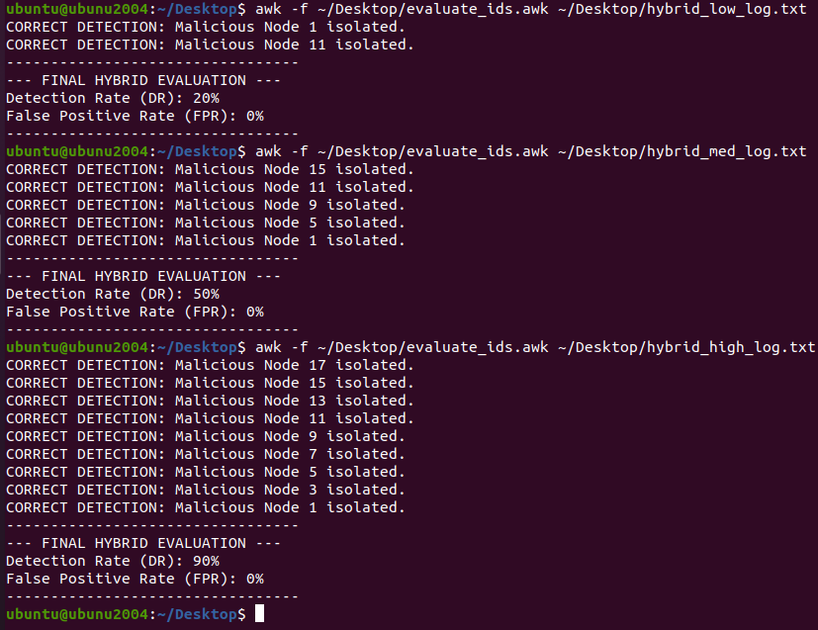
Figure 18: Detection rates of the Hybrid system along with the false positive rate.
Figure 19: Normal Sim Throughput
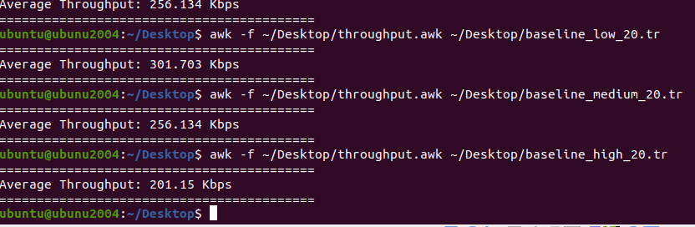
Figure 20: Low, medium, high Hybrid Throughput
Figure 21: 10% Malicious Hybrid PDR
Figure 22: 10% Malicious Hybrid Delay
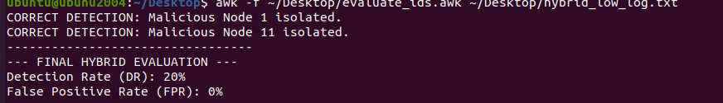
Figure 23: 10% Malicious Hybrid detection and false positive rate
Figure 24: 25% Malicious Hybrid PDR
Figure 25: 25% Malicious Hybrid Delay
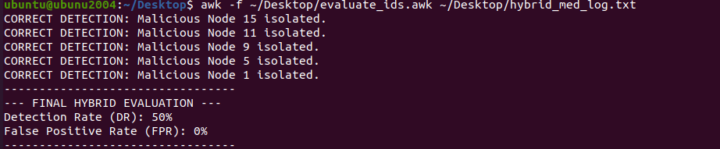
Figure 26: 25% Malicious Hybrid detection and false positive rate

Figure 27: 50% Malicious Hybrid PDR
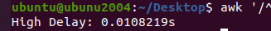
Figure 28: 50% Malicious Hybrid Delay
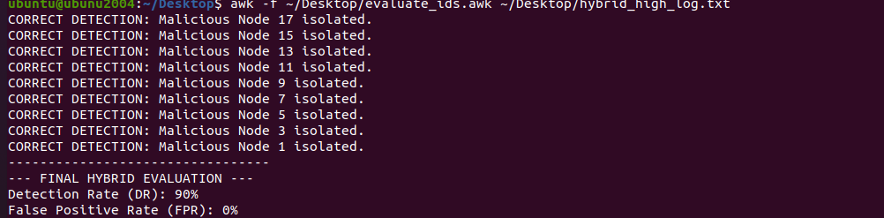
Figure 29: 50% Malicious Hybrid detection and false positive rate

Appendix C- IDS Screenshots

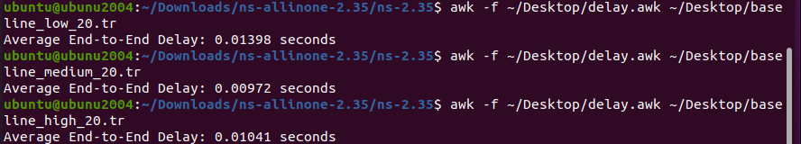
Figure 30: IDS only Delay
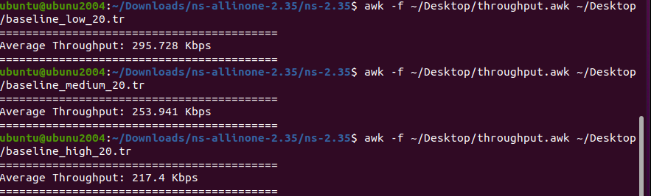
Figure 31: IDS Only throughput
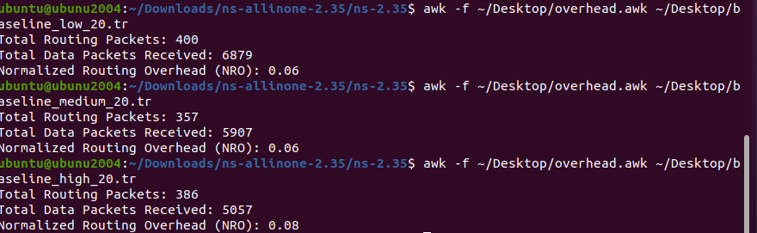
Figure 32: IDS Only Routing Overhead
Figure 33: 10% IDS PDR Results
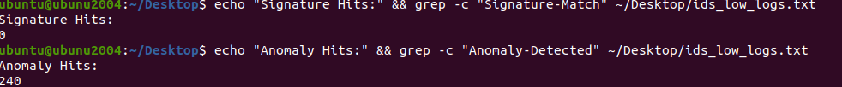
Figure 34: IDS Signature Hits

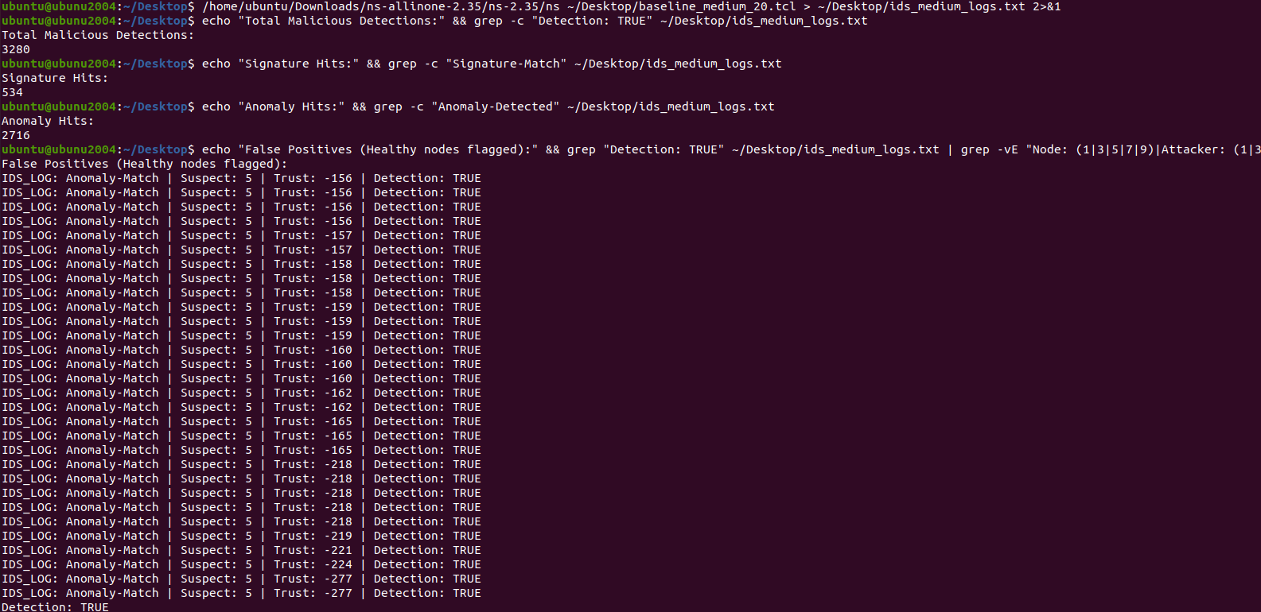
Figure 35: 25% Malicious IDS
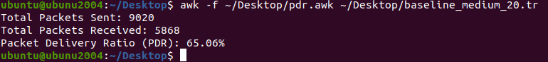
Figure 36: 25% Malicious IDS PDR

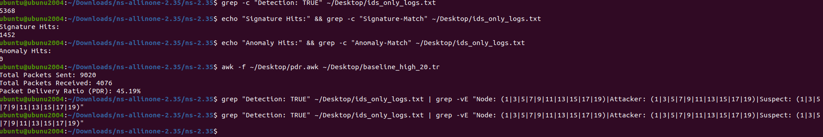
Figure 37: 50% IDS PDR

Appendix D- Trust-based Screenshots

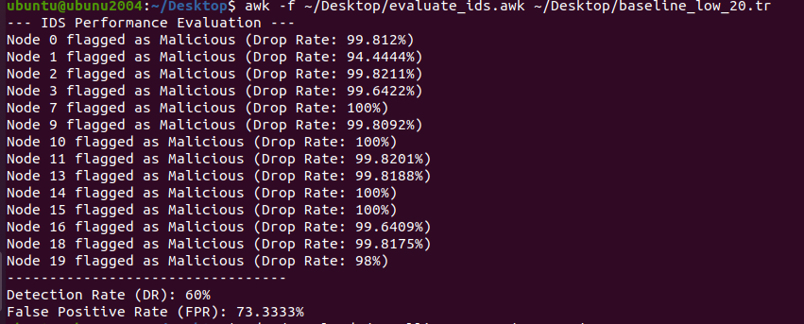
Figure 38: 10% Malicious PDR
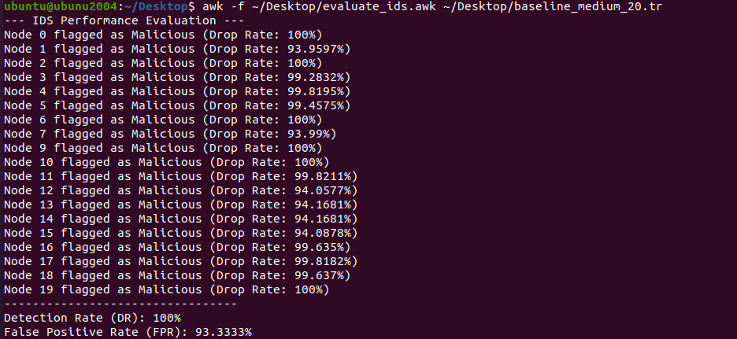
Figure 39: 25% Malicious PDR
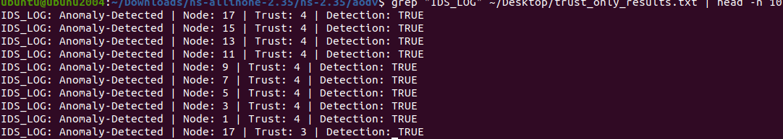
Figure 40: Grep results showing the high false positive rate

Figure 41: 50% Malicious PDR
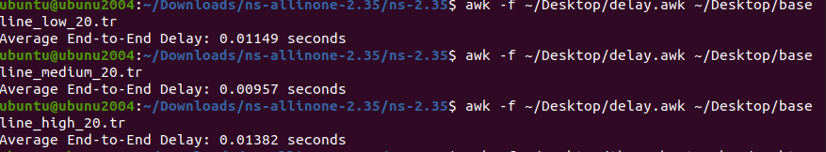
Figure 42: Trust based only Delay
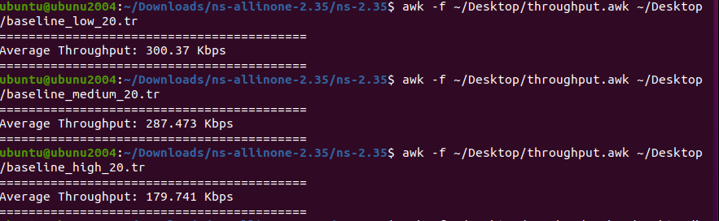
Figure 43: Trust based only Throughput
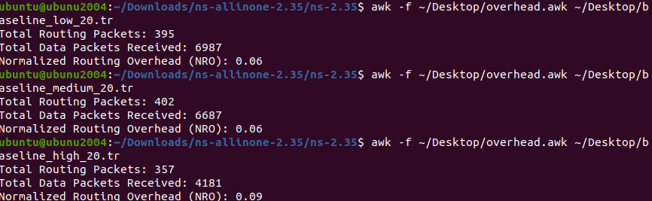
Figure 44: Trust based only Routing Overhead

